

**CSE302: Database Systems (Section 1)**

**[SUMMER 2022]**

**Project Report**

Project/Application Title: Capstone student marking system

**Project URL/Link:https:**//apex.oracle.com/pls/apex/r/cse302_project_capstone_marking/capston-marking/

**Submitted by:**

| **Student ID** | **Student Name** | **Contribution Percentage** |
| --- | --- | --- |
| **2020-1-60-196** | **Md.Abid Sarkar** | **40%** |
| **2020-1-60-075** | **Afsana Hossain Esha** | **30%** |
| **2020-1-60-030** | **Mashrufa** | **30%** |
|  |  |  |
|  |  |  |

# Final version of the E-R Model of the Project

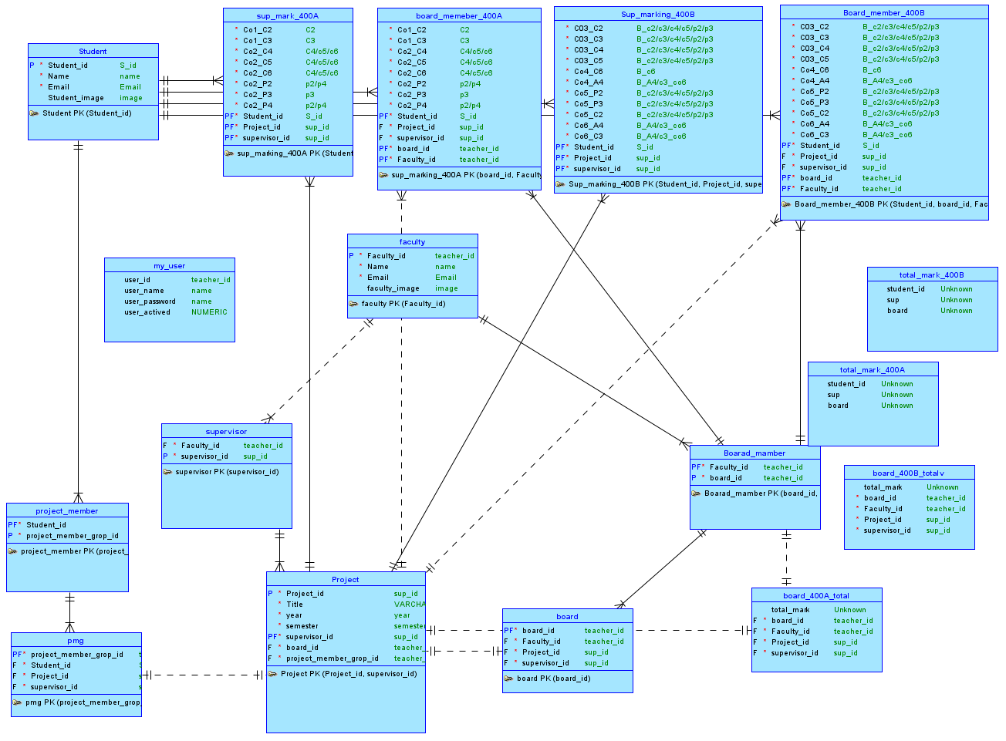

# Final Version of the Relational Data Model of the Project

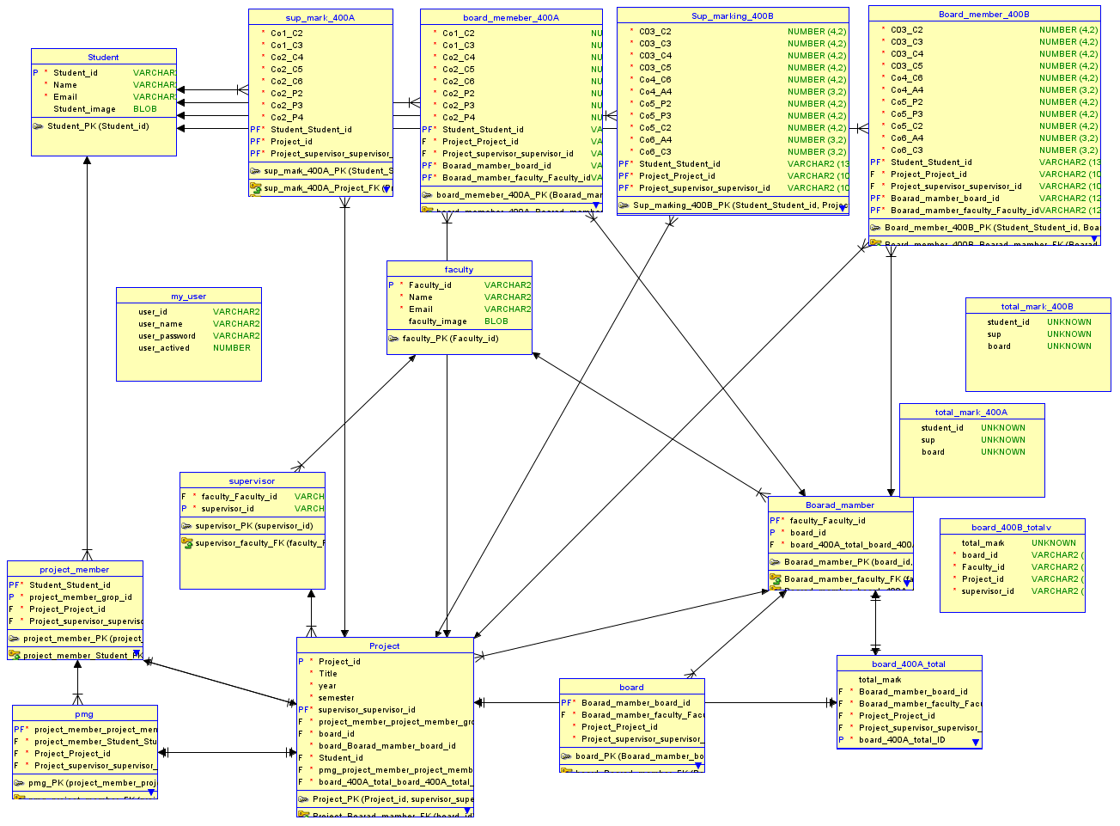

# Implementation Checklist

| Description | Remarks |
| --- | --- |
| Project ID | 128482 |
| Workspace Name | cse302_project_capstone_marking |
| Workspace Email | 2020-1-60-196@STD.EWUBD.EDU |
| Workspace Password | ewucse3021 |
|  |  |
| Authentication Type | Custom |
| Username and Password to Login |  |
| write username like admin | write password like *admin123* |
| if you have multiple users, write all username and password correctly | **#administrator**  admin *admin123*  abid *abid123*  esha *esha123*  mash *mash123*  ***#*contributor as faculty**  f0001 *f1234*  f0002 *f123*4  to  f0026 *f123*  *#***contributor as supervisor**  sf0001 *sf1234*  SF0002 *Sf1234*  SF0003 *Sf1234*  SF0004 *Sf1234*  SF0005 *Sf1234*  SF0006 *Sf1234*  SF0007 *Sf1234*  SF0008 *Sf1234*  SF0009 *Sf1234*  SF0010 *Sf1234*  SF0018 *Sf1234* |
|  |  |
|  |  |
| Uploaded and Displayed Images in Reports | yes |
| Implemented Page-wise Authorization | yes |
|  |  |
| Number of Reports with Forms | 10 |
| Number of Master-detail Forms | 2 |
| Number of Reports based on Queries, Aggregate Queries | 17 |
| Number of Parameterized Reports | 11 |
| Number of Graphs/Charts | 3 |
|  |  |
| Included any trigger/other feature which is not taught in class. If yes, please explain briefly. | display reports based on who log in, add image into login page, add favicon, add captcha on login page,upload from excel file, change icone,Breadcrumb, |
| Write the most unique feature/functionality in your application or the page of your application that you are proud of. Explain briefly. | making a report or taking input based on who log in. suppose a student log in he did not need to provide any id automatically he only showed his own result. or if a supervisor login he can only mark his own student and in dropdown he can only see project id,student or etc besd on administer assign project ,student. This help us to remove wrong information input. |

# Reports with Forms

| Report Page Number and Name | Form Page Number and Name | Table |
| --- | --- | --- |
| Student Report  Page-7 | Student form  Page-2 | student |
| Faculty Report  Page-6 | Faculty form  Page-5 | faculty |
| Board Member Report  Page-13 | Board member form  Page-8 | board member |
| 400 A Board Marking Report  Page-22 | 400 A Board Mark form  Page-20 | BOARD_MEMBER_400A |
| Project Report  Page-24 | Project form  Page-21 | project |
| 400B Sup Marking Report  Page-26 | 400B Sup Marking form  Page-25 | sup_mark_400B |
| Project Member Report  Page-29 | Project Member form  Page-31 | project_member |
| 400B Board Mark Report  Page-32 | 400B Board Mark form  Page-30 | board_member_400B |
| 400A Sup Mark Report  Page-34 | 400A Sup Mark form  Page-40 | sup_marking_400A |
| Supervisor Report  Page-36 | Supervisor form  Page-16 | supervisor |
| Sup_400A_total  Page-43 |  |  |
| Sup 400B total  Page-45 |  |  |
| User_profile_S  Page-48 |  |  |
| User_Profile_SF  Page-49 |  |  |
| Supervisor_list  Page-50 |  |  |
| Board 400A total  Page-52 |  |  |
| Boar 400B total  Page-54 |  |  |
| Final 400A Student  Page-71 |  |  |
| Final 400B  Page-73 |  |  |
| Final 400B S  Page-75 |  |  |
| Student Info Faculty  Page-77 |  |  |
| Student Info Supervisor  Page-79 |  |  |
| User_Profile_F  Page-14 |  |  |
| 400A Submit Manually  Page-15 |  |  |
|  |  |  |
|  |  |  |
|  |  |  |
|  |  |  |
|  |  |  |

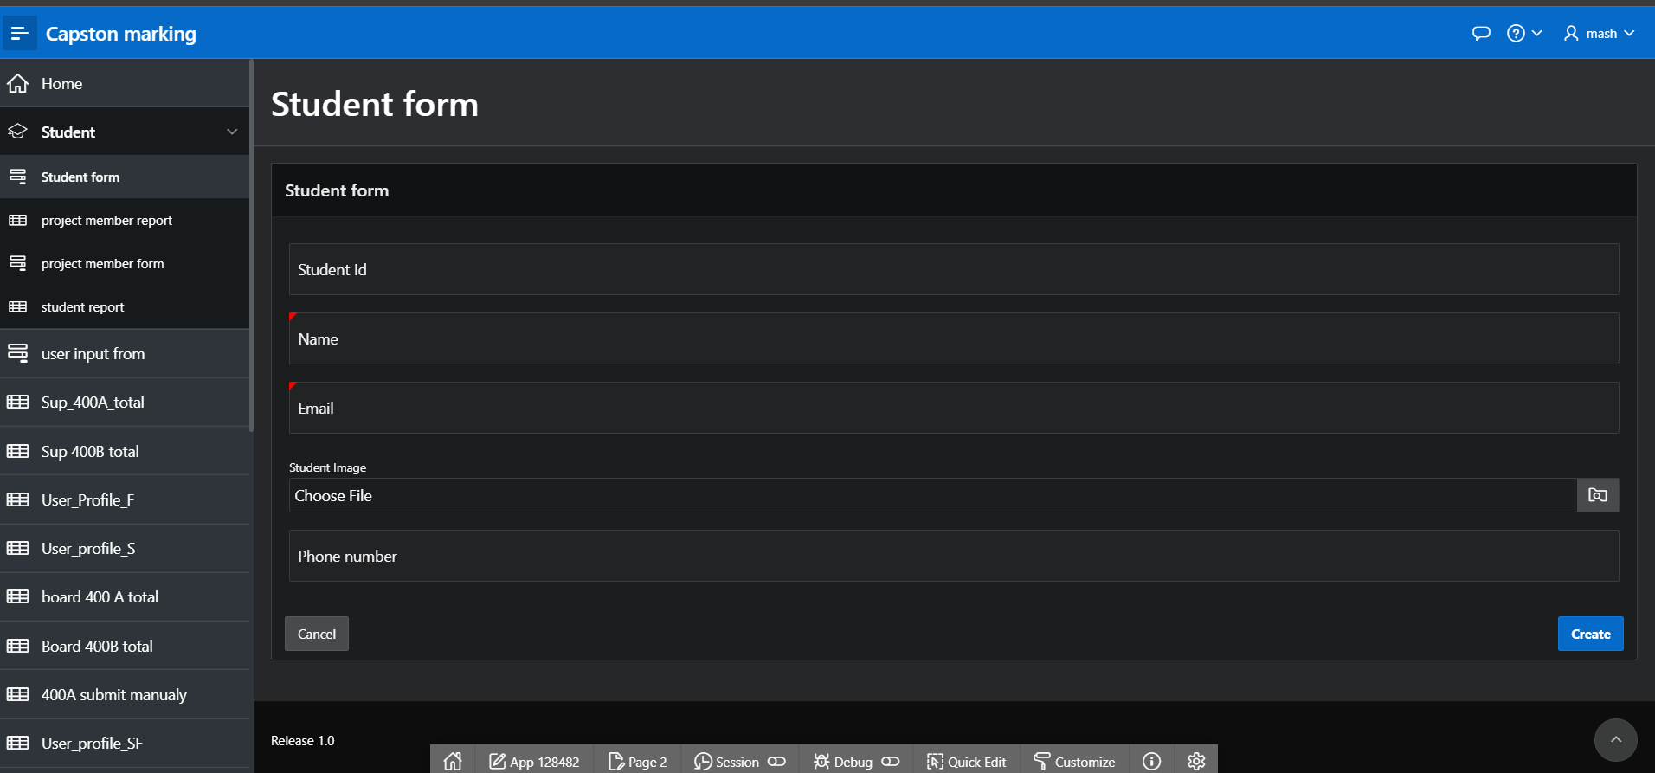

Figure 4.1:Student form

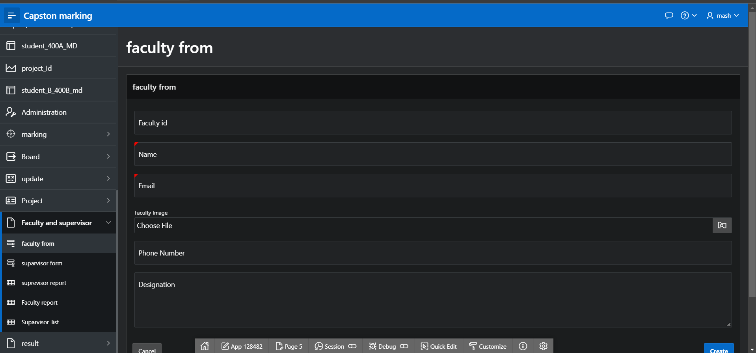

Figure 4.2:Faculty form

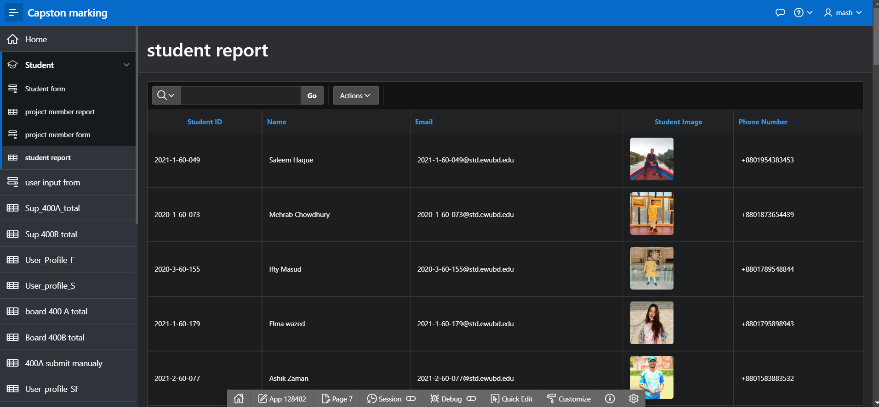

Figure 4.3:Student report

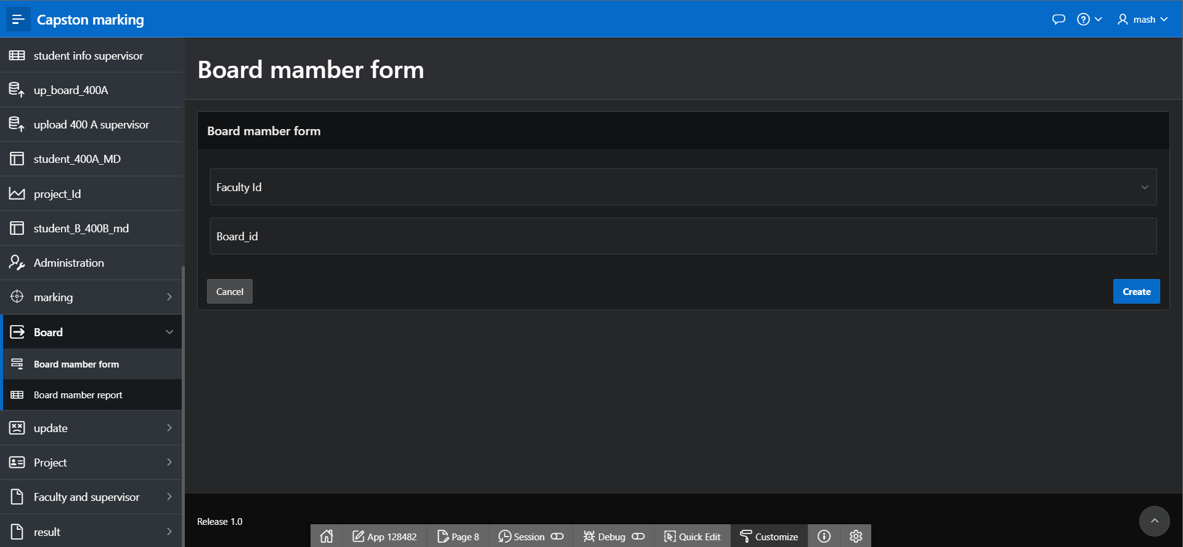

Figure 4.4:Board member form

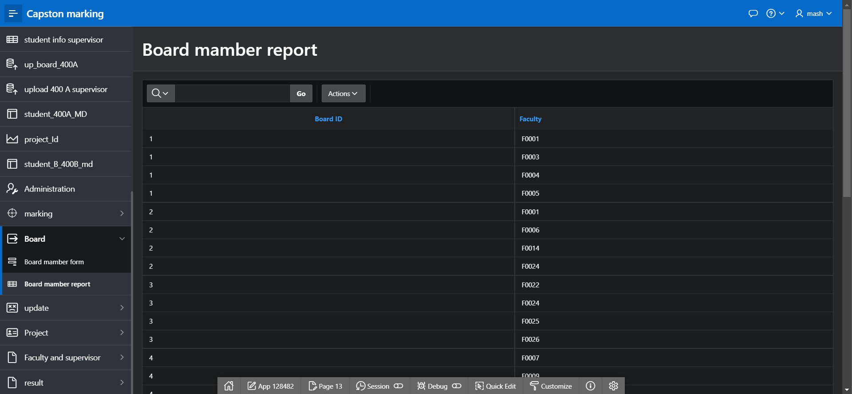

Figure 4.5:Board member report

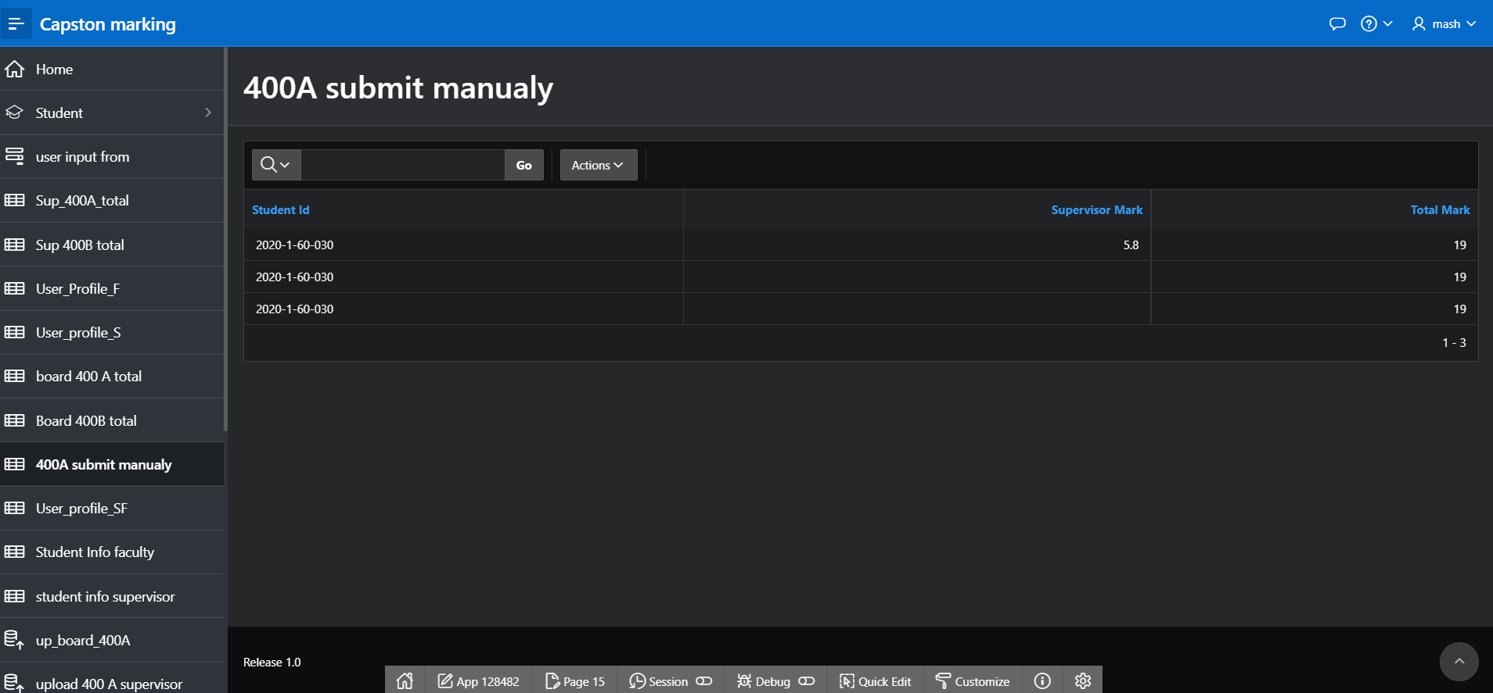

Figure 4.6:400A Submit manually

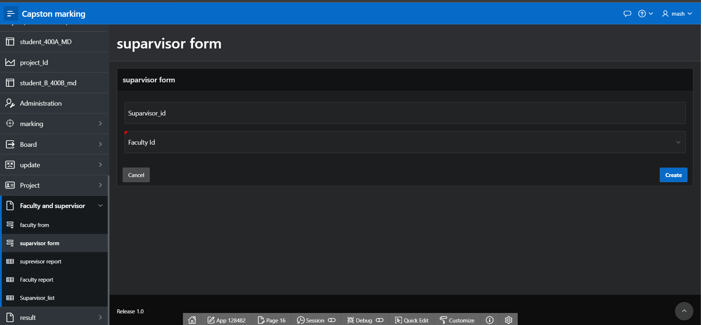

Figure 4.7:supervisor form

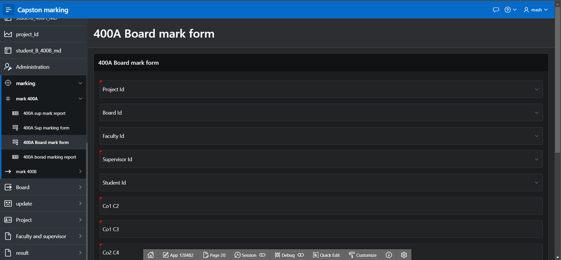

Figure 4.8:400A board mark form

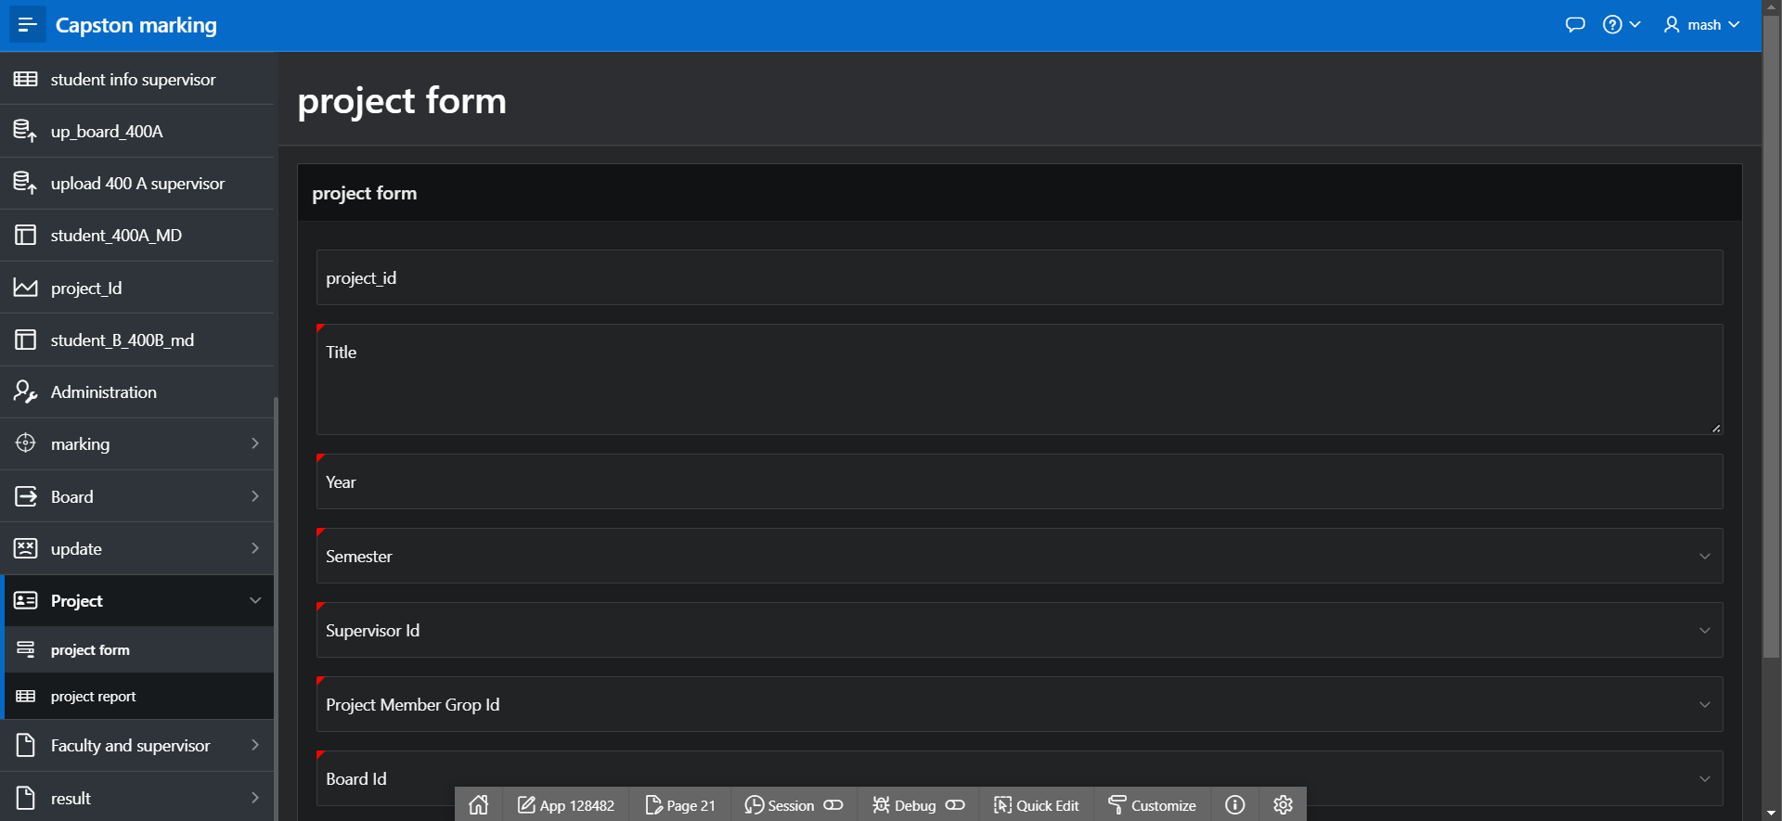

Figure 4.9: project form

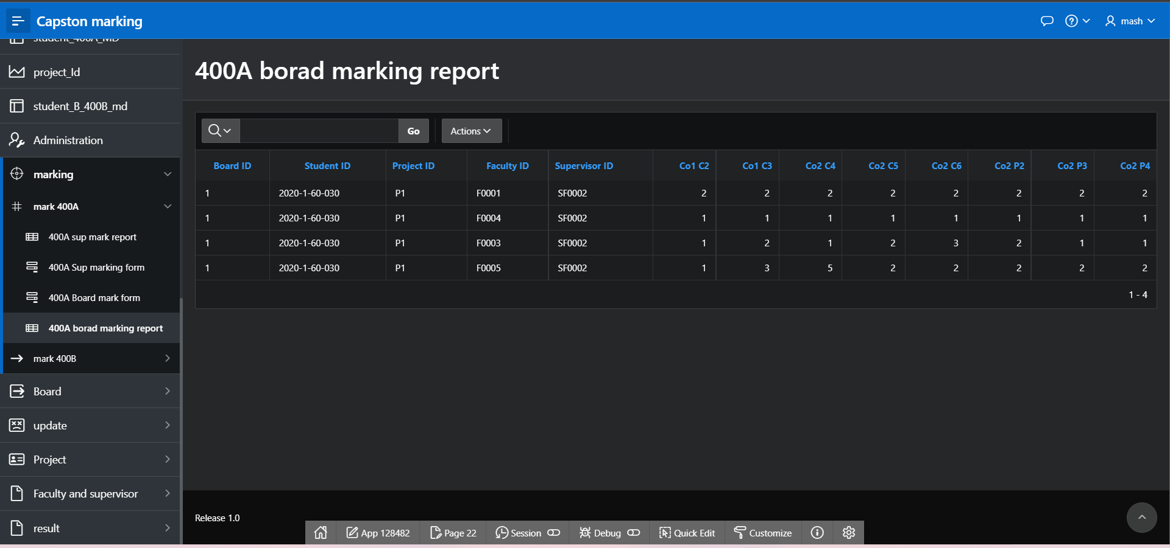

Figure 4.10: 400A board marking report

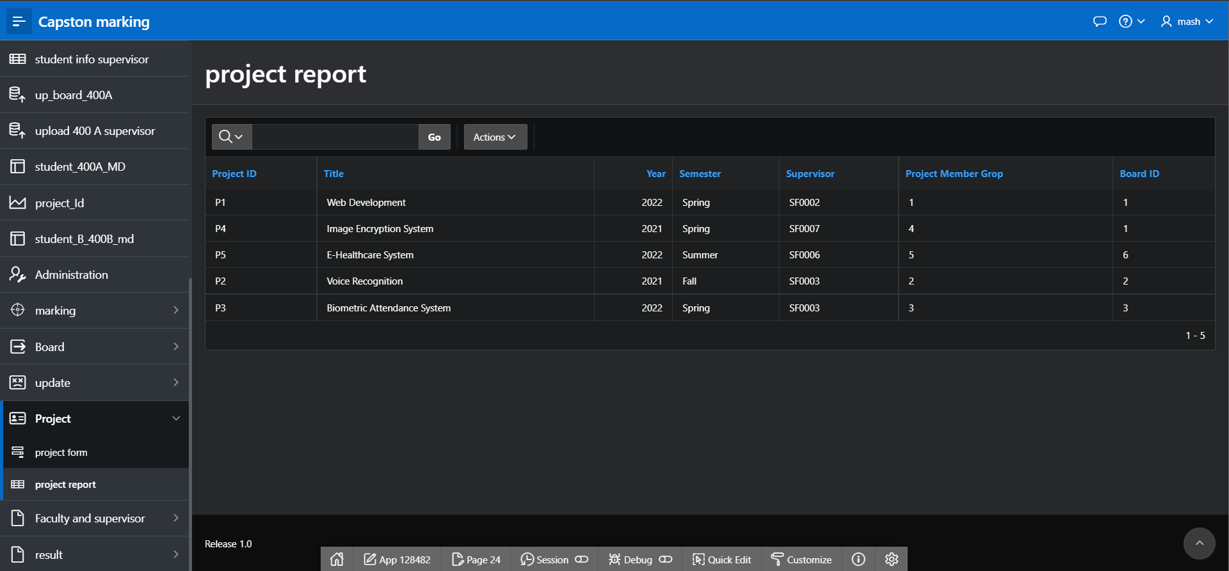

Figure 4.11: project report

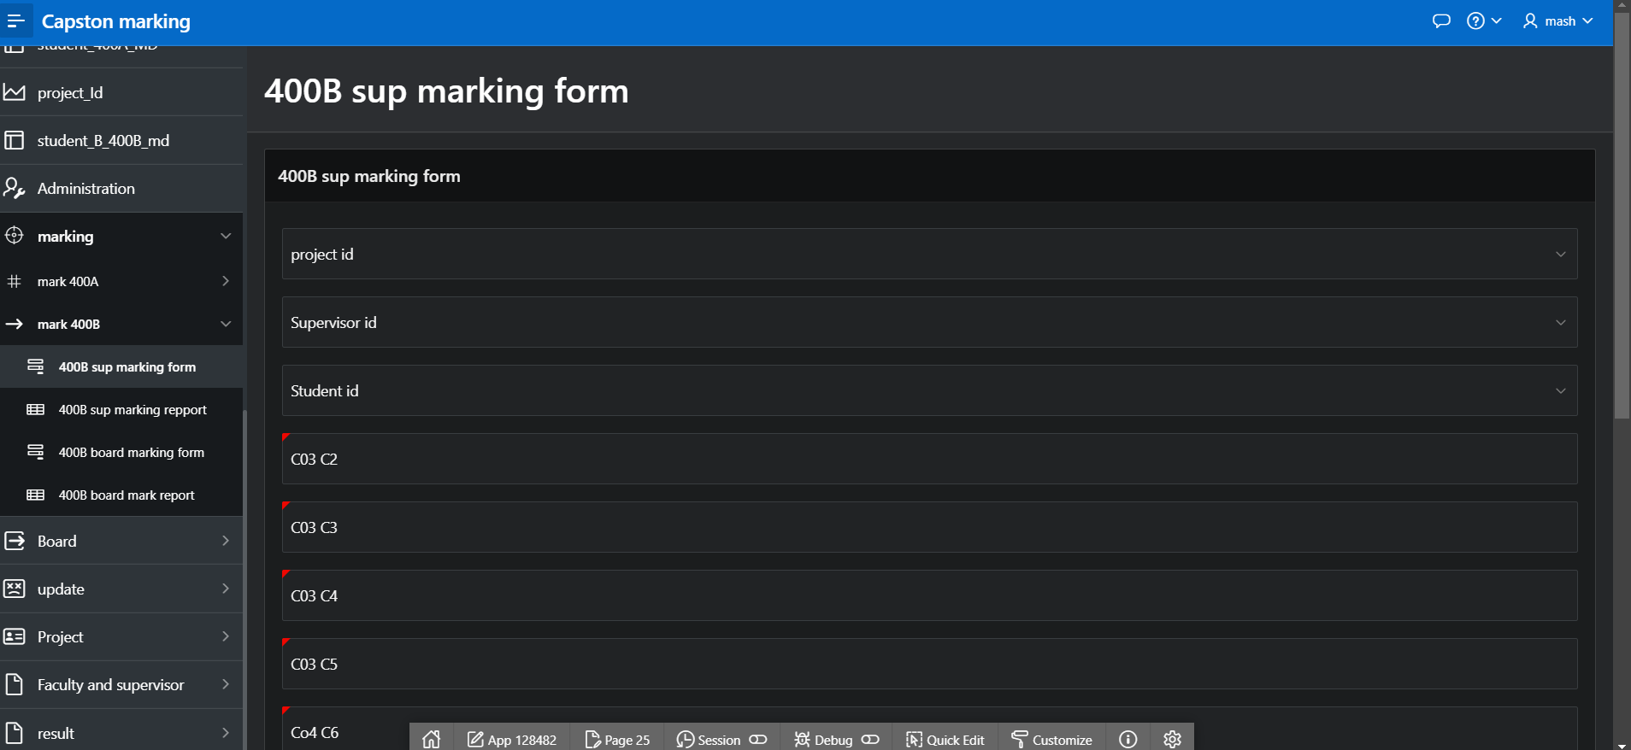

Figure 4.12: 400B sup marking form

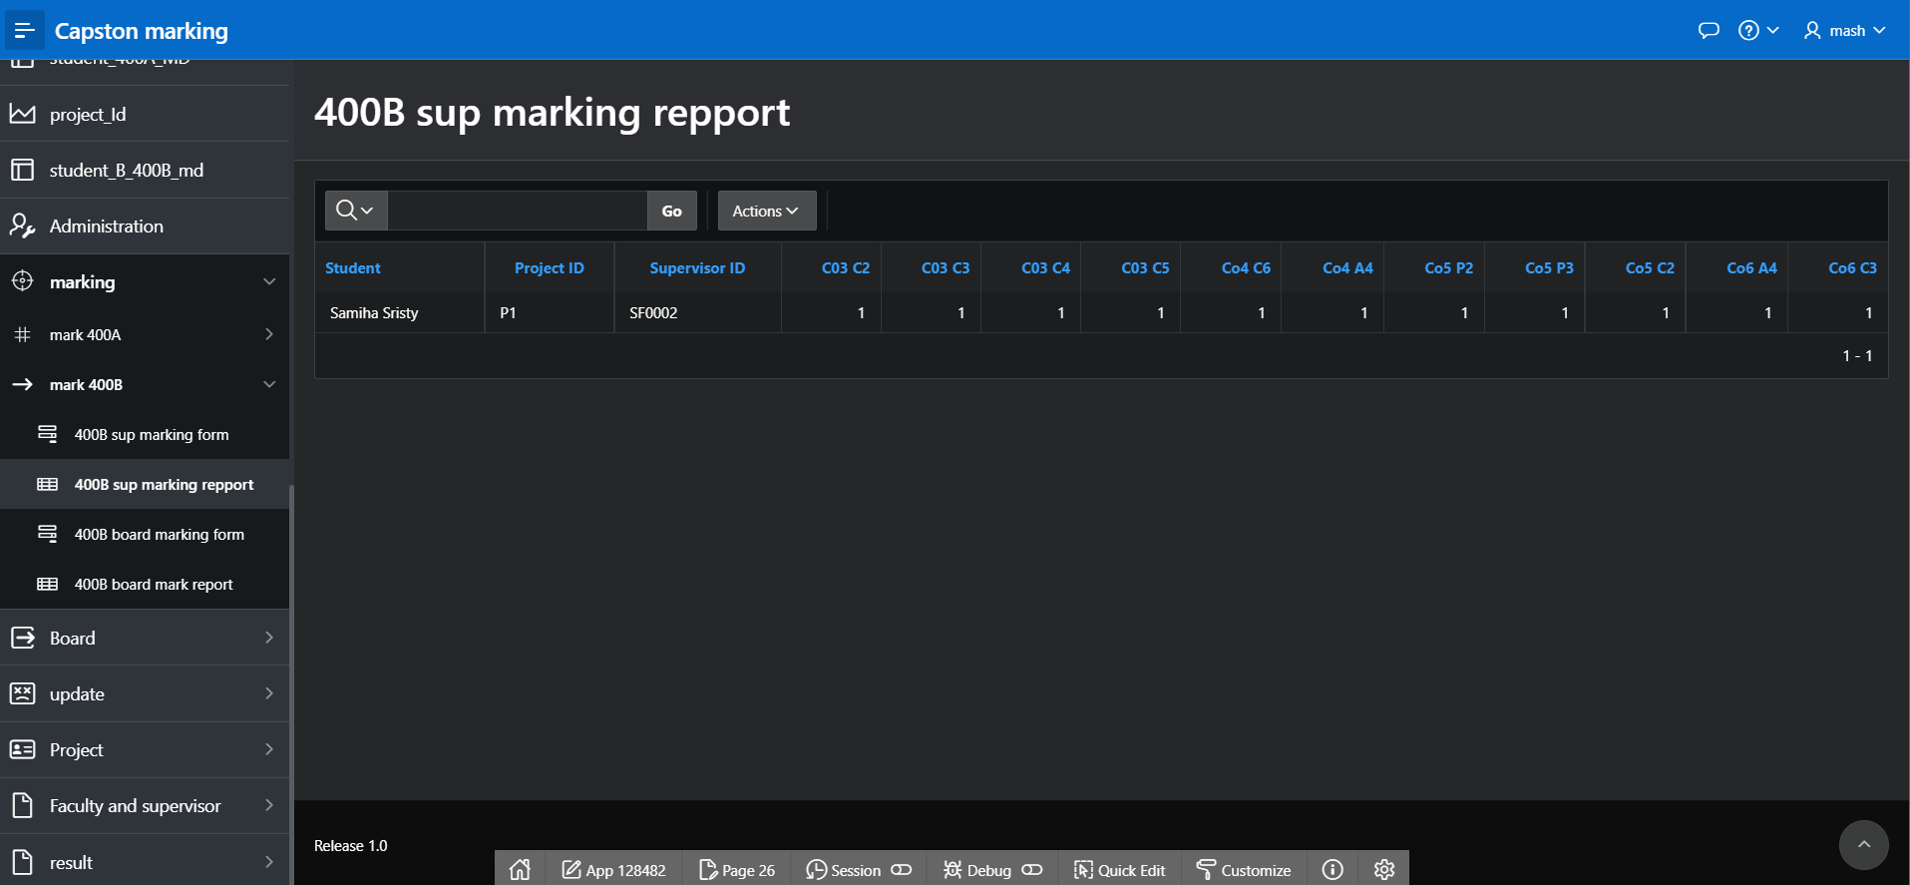

Figure 4.13: 400B sup marking report

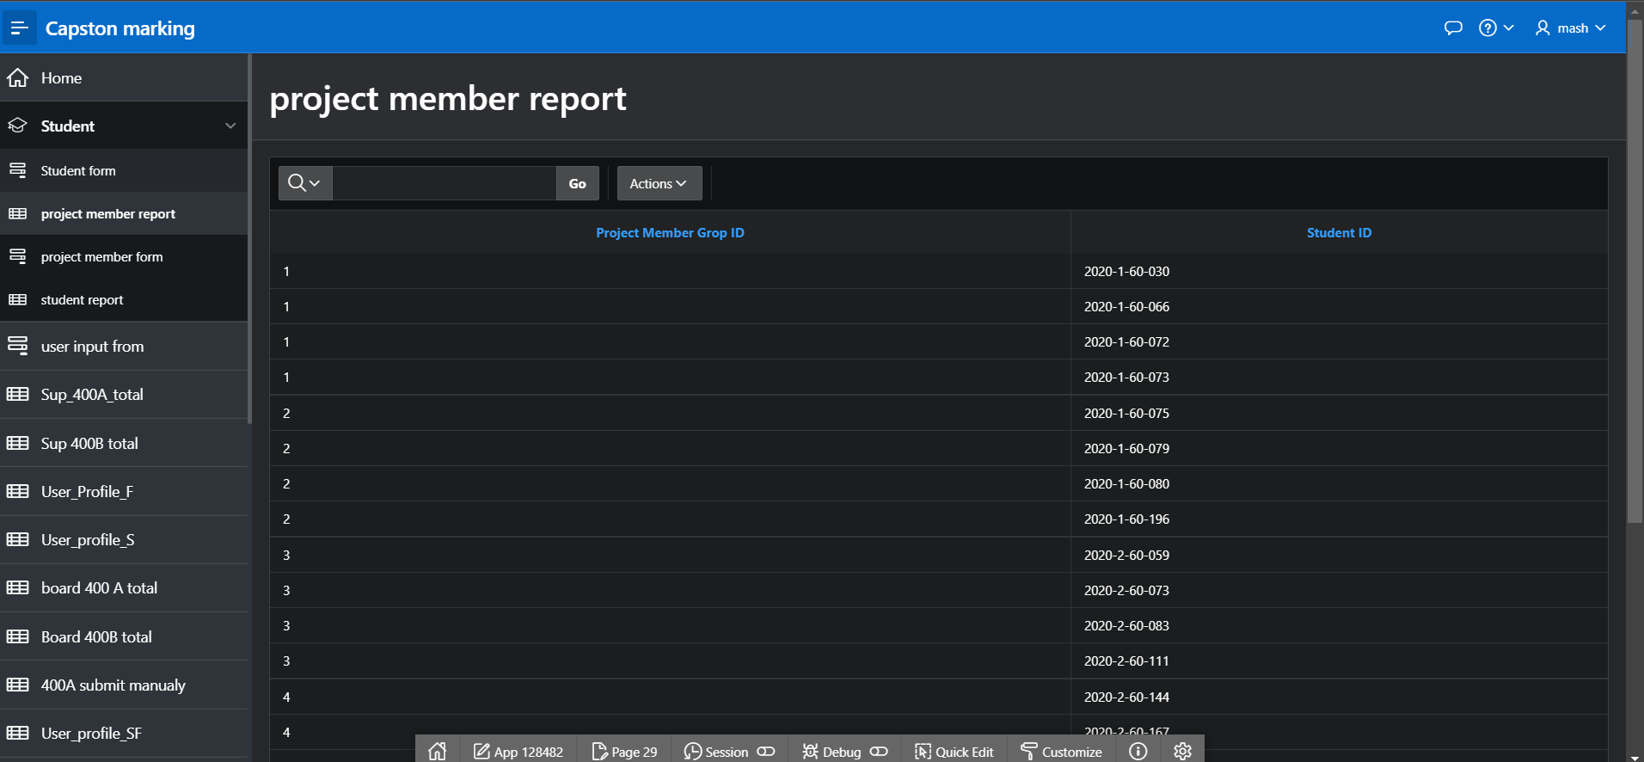

Figure 4.14: 400B sup marking report

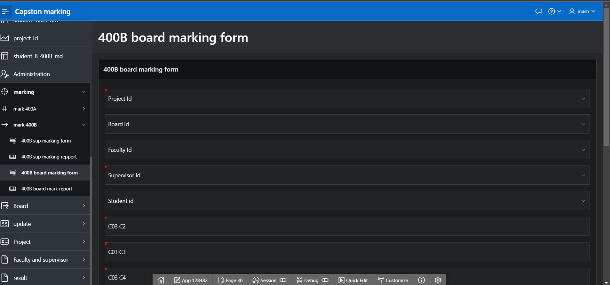

Figure 4.15: 400B board marking form

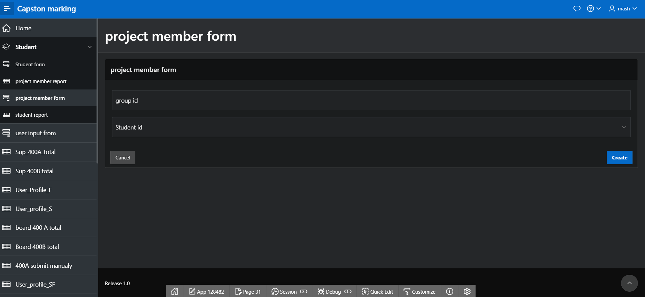

Figure 4.16:project member form

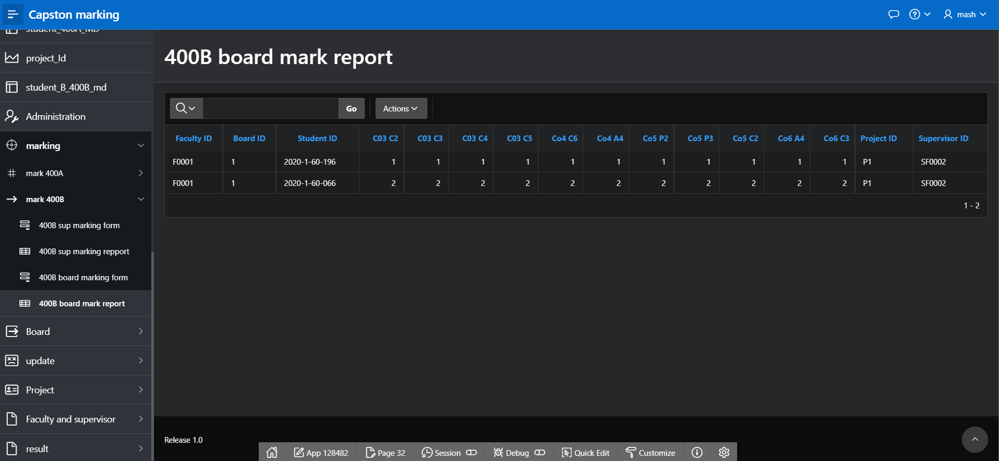

Figure 4.17: 400B board marking report

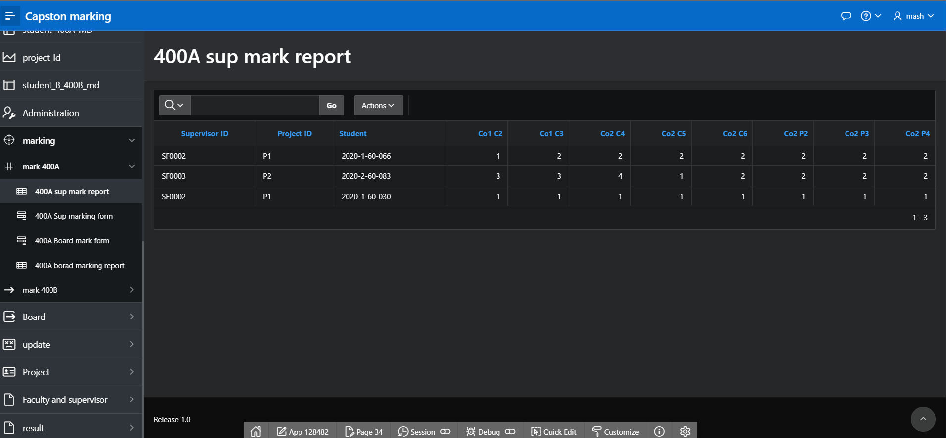

Figure 4.18: 400B sup mark report

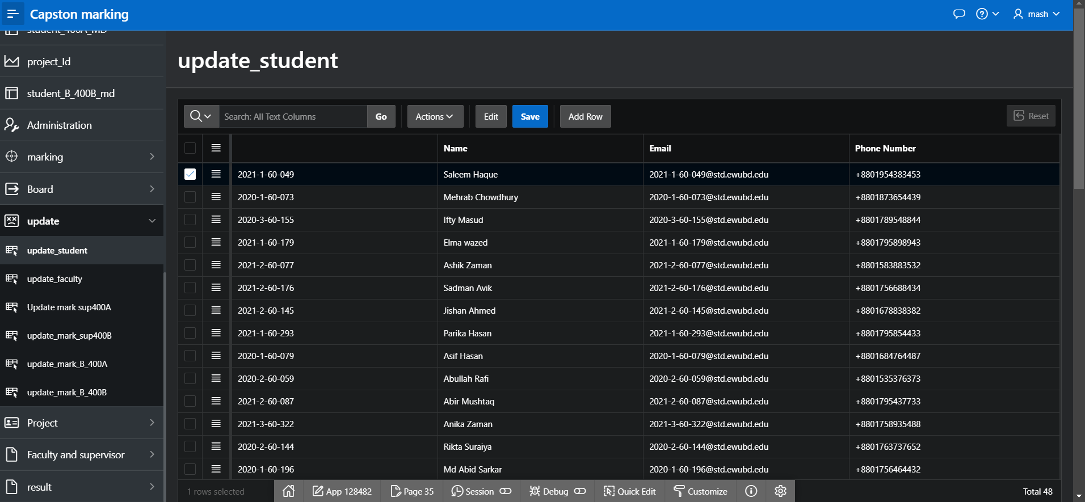

Figure 4.19: update student

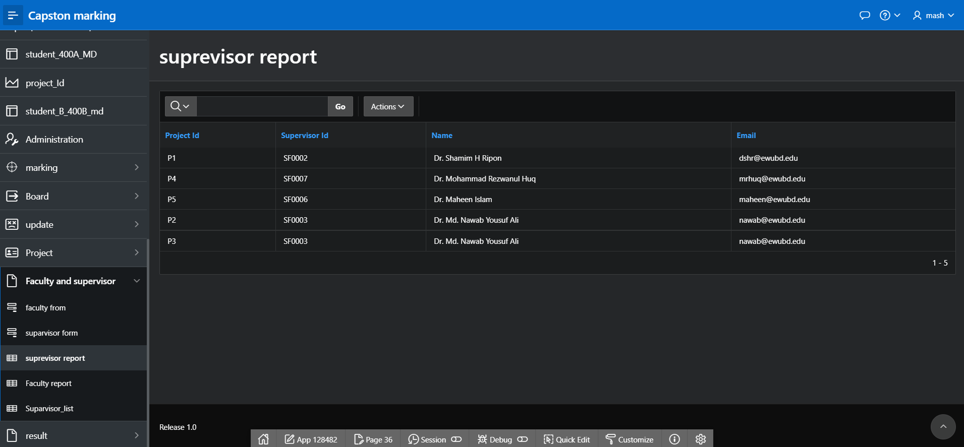

Figure 4.20: supervisor report

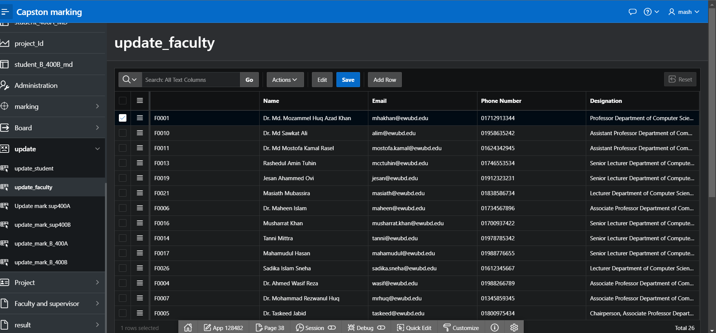

Figure 4.21: update faculty

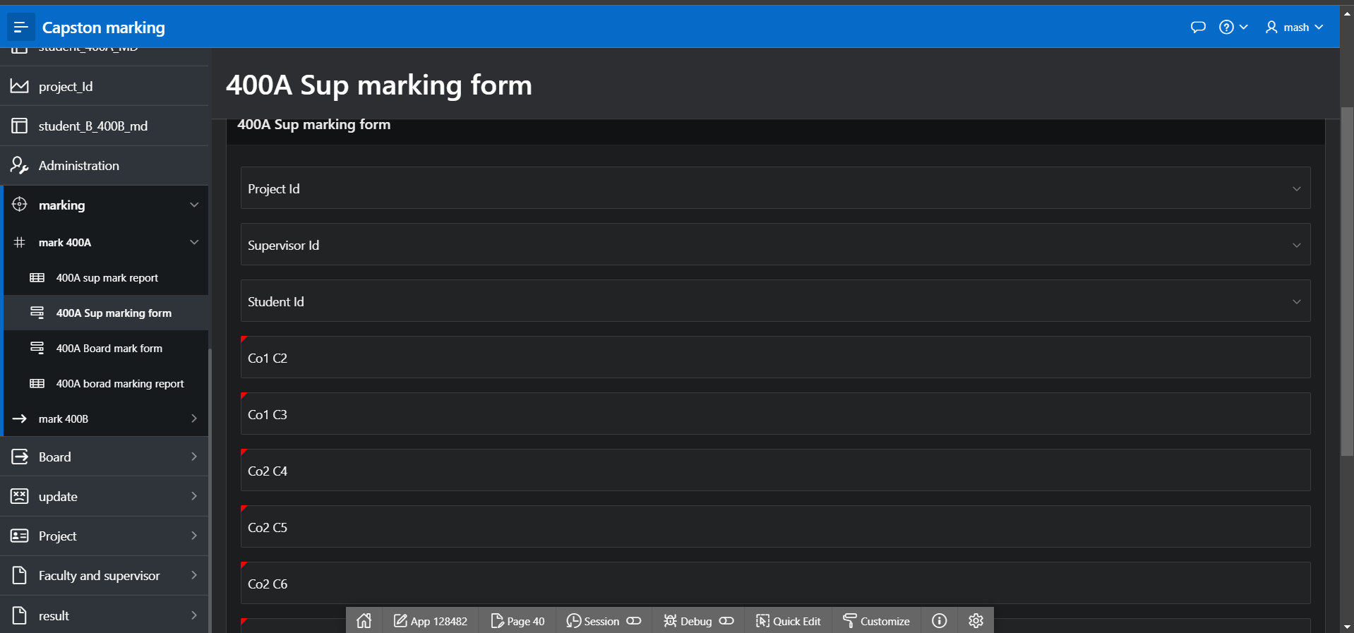

Figure 4,22: 400A sup marking form

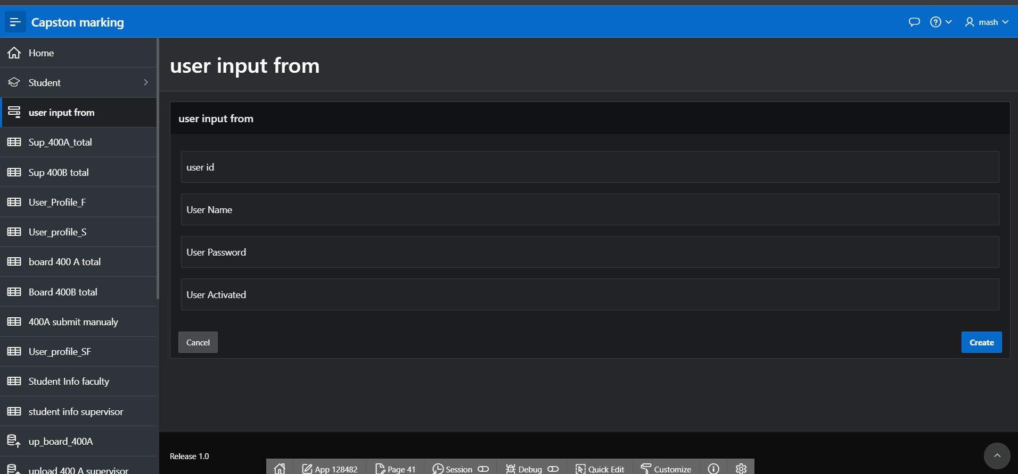

Figure 4,23: User input form

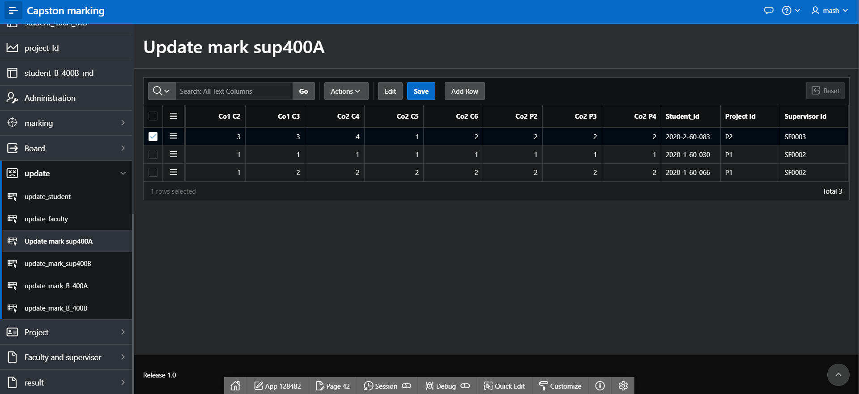

Figure 4.24: Update mark sup 400A

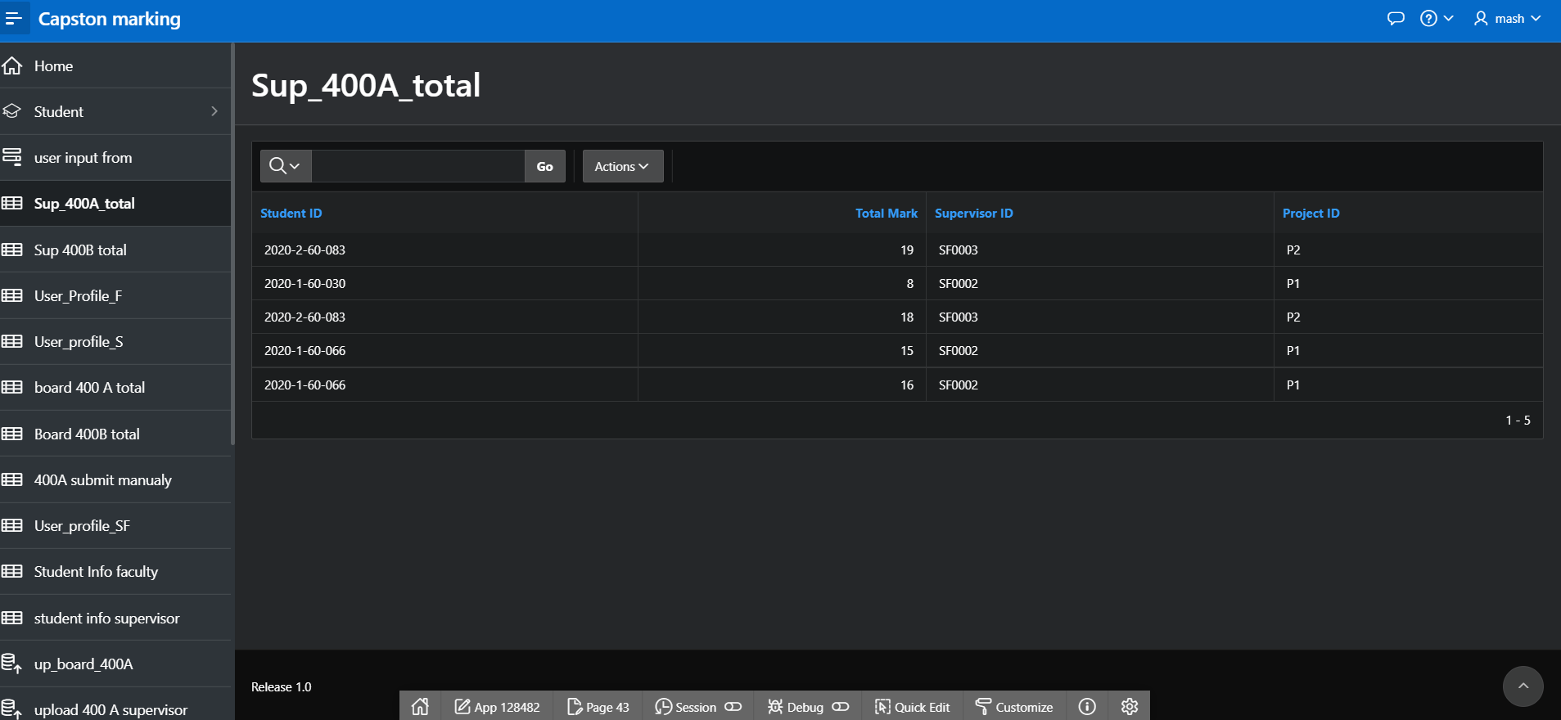

Figure 4.25: Sup 400A total

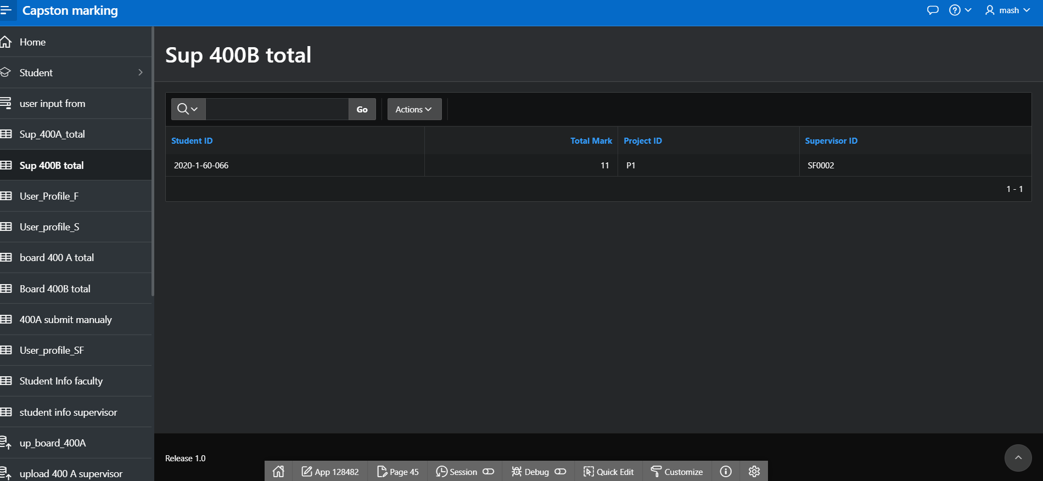

Figure 4.26: Sup 400B total

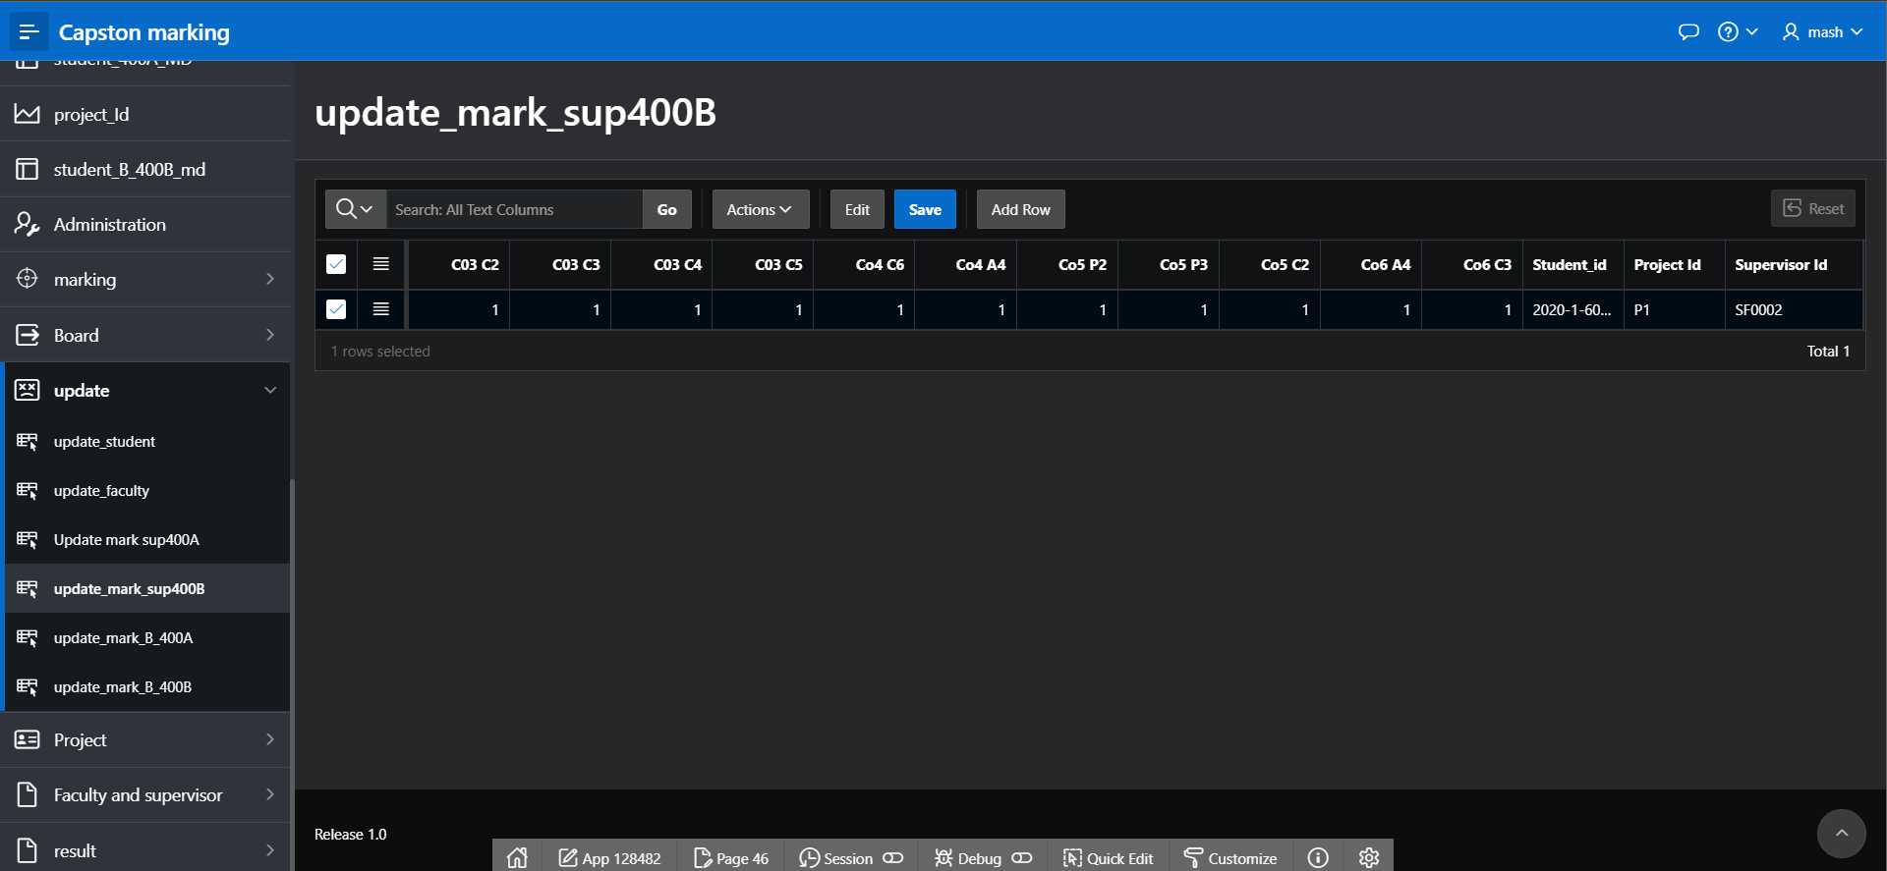

Figure 4.27: update mark sup 400B

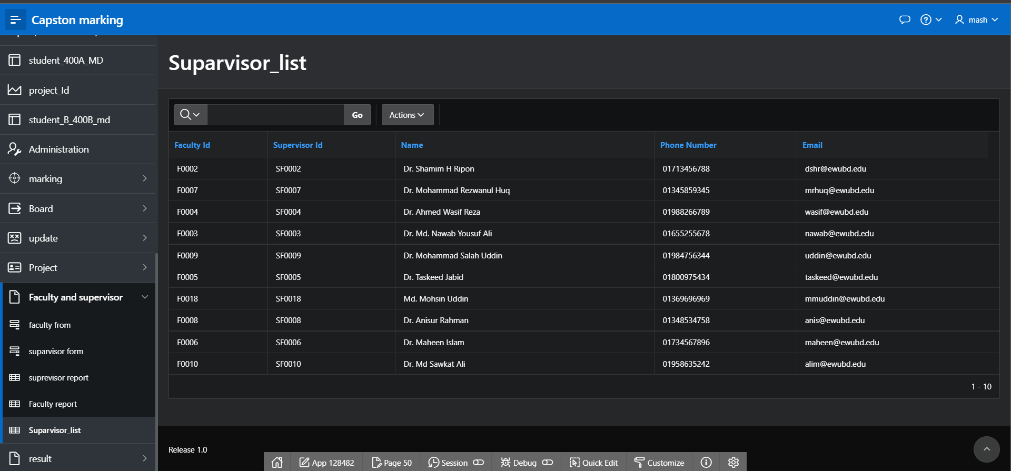

Figure 4.28: Supervisor list

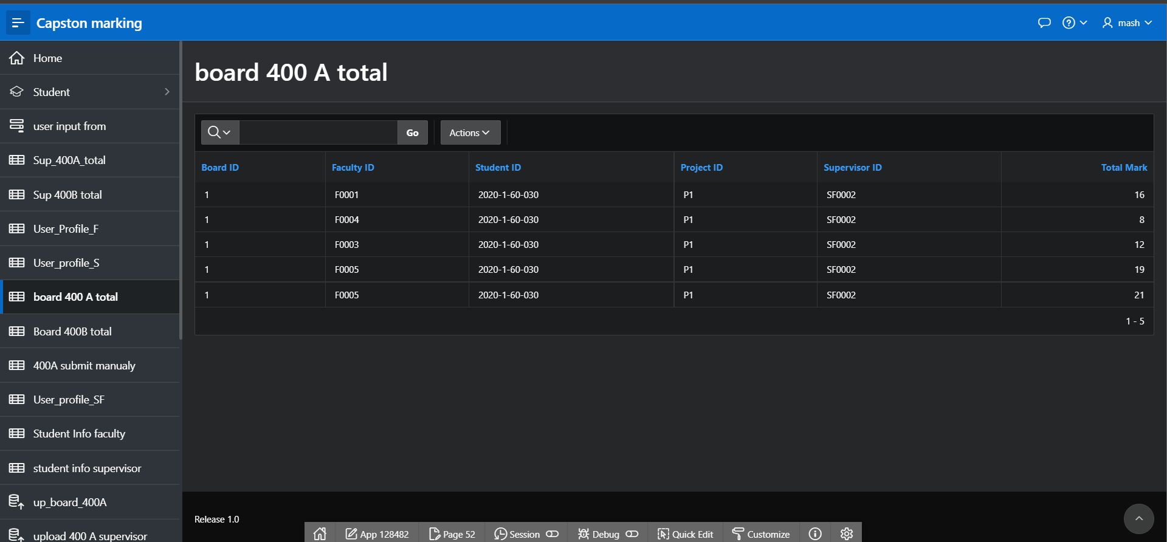

Figure 4.29: Board 400A total

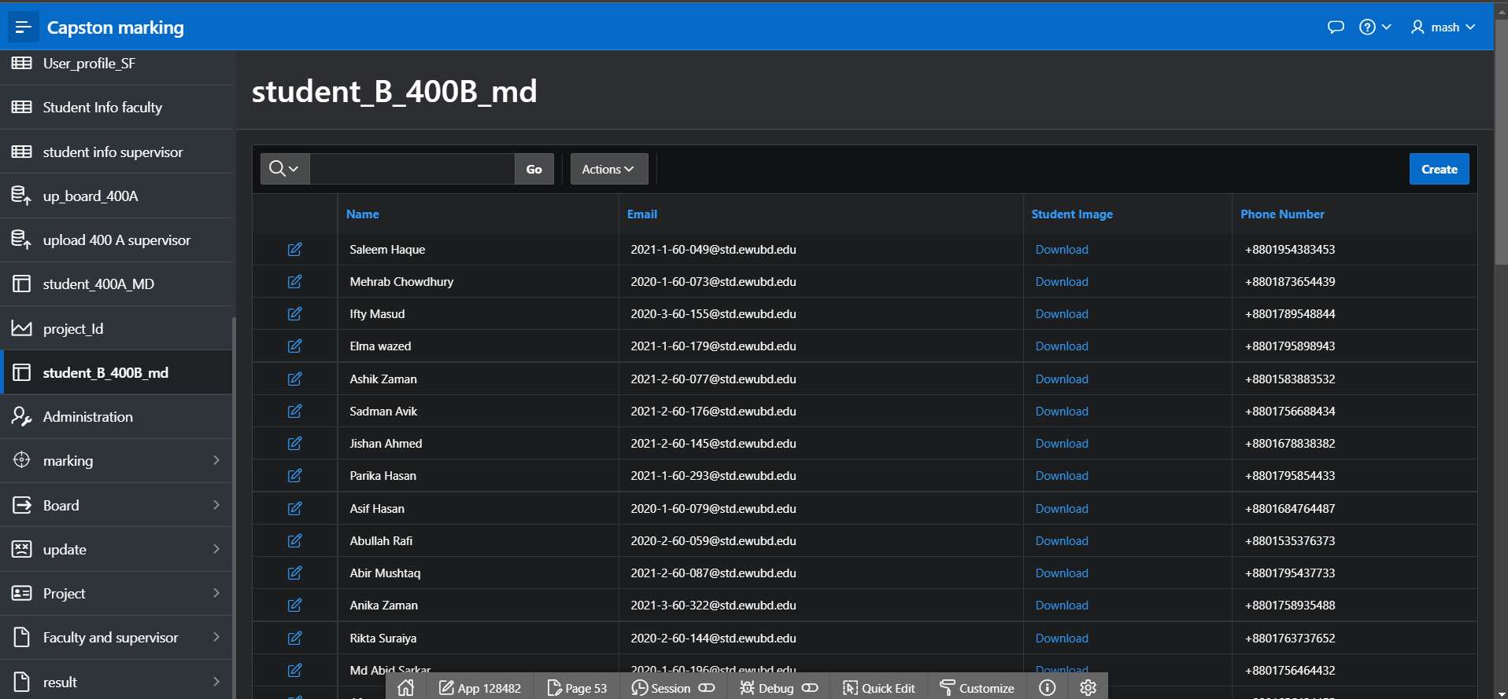

Figure 4.30: Student B 400B MD

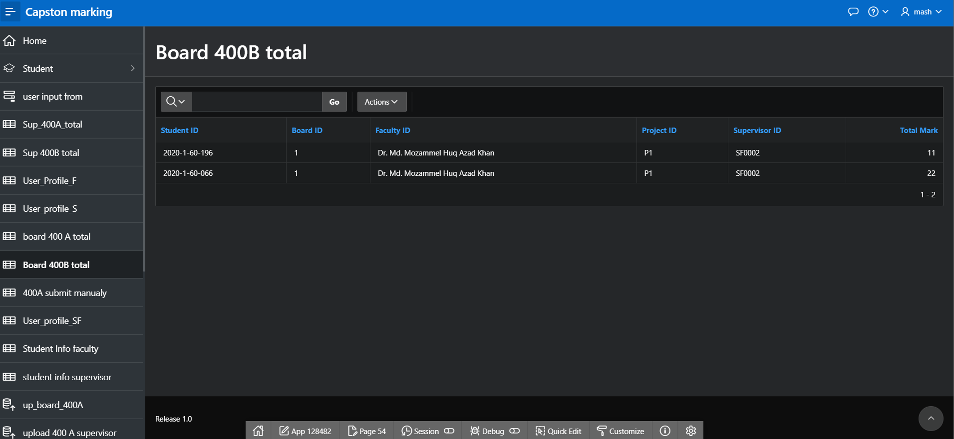

Figure 4.31: Board 400B total

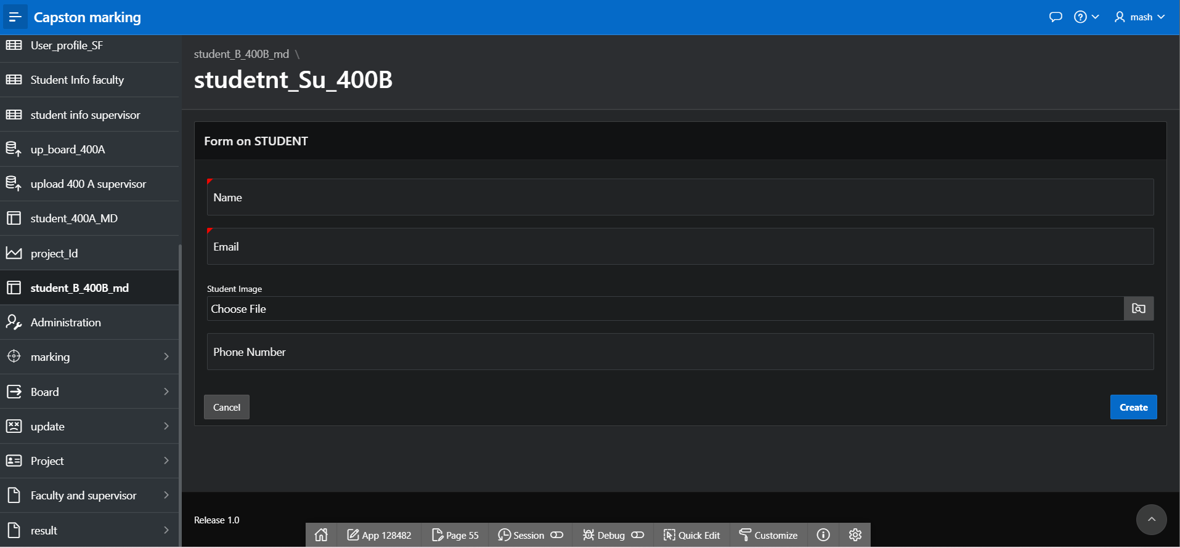

Figure 4.32: Student Su 400B

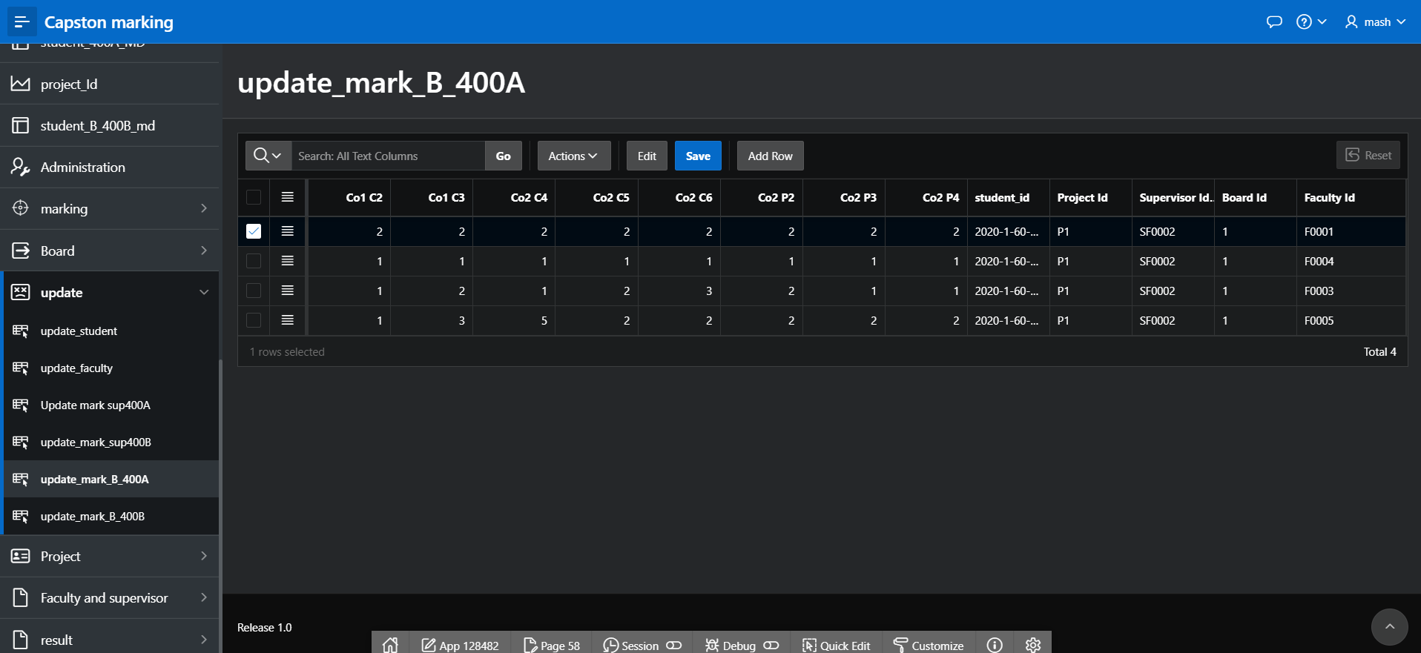

Figure 4.33: Update mark B 400A

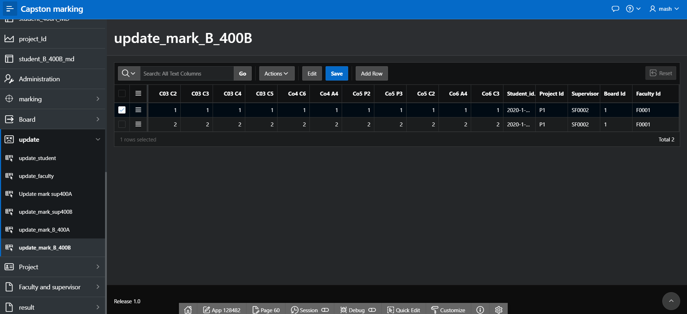

Figure 4.34: Update mark B 400B

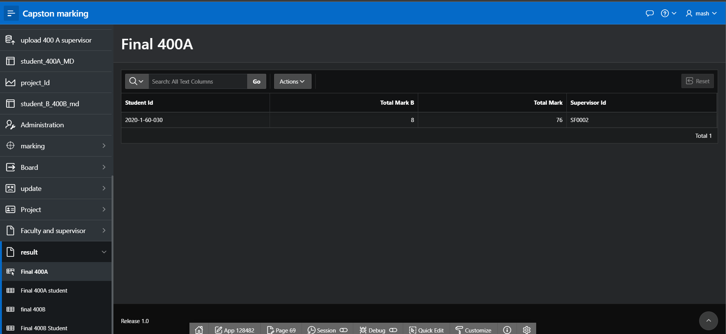

Figure 4.35: Final 400A

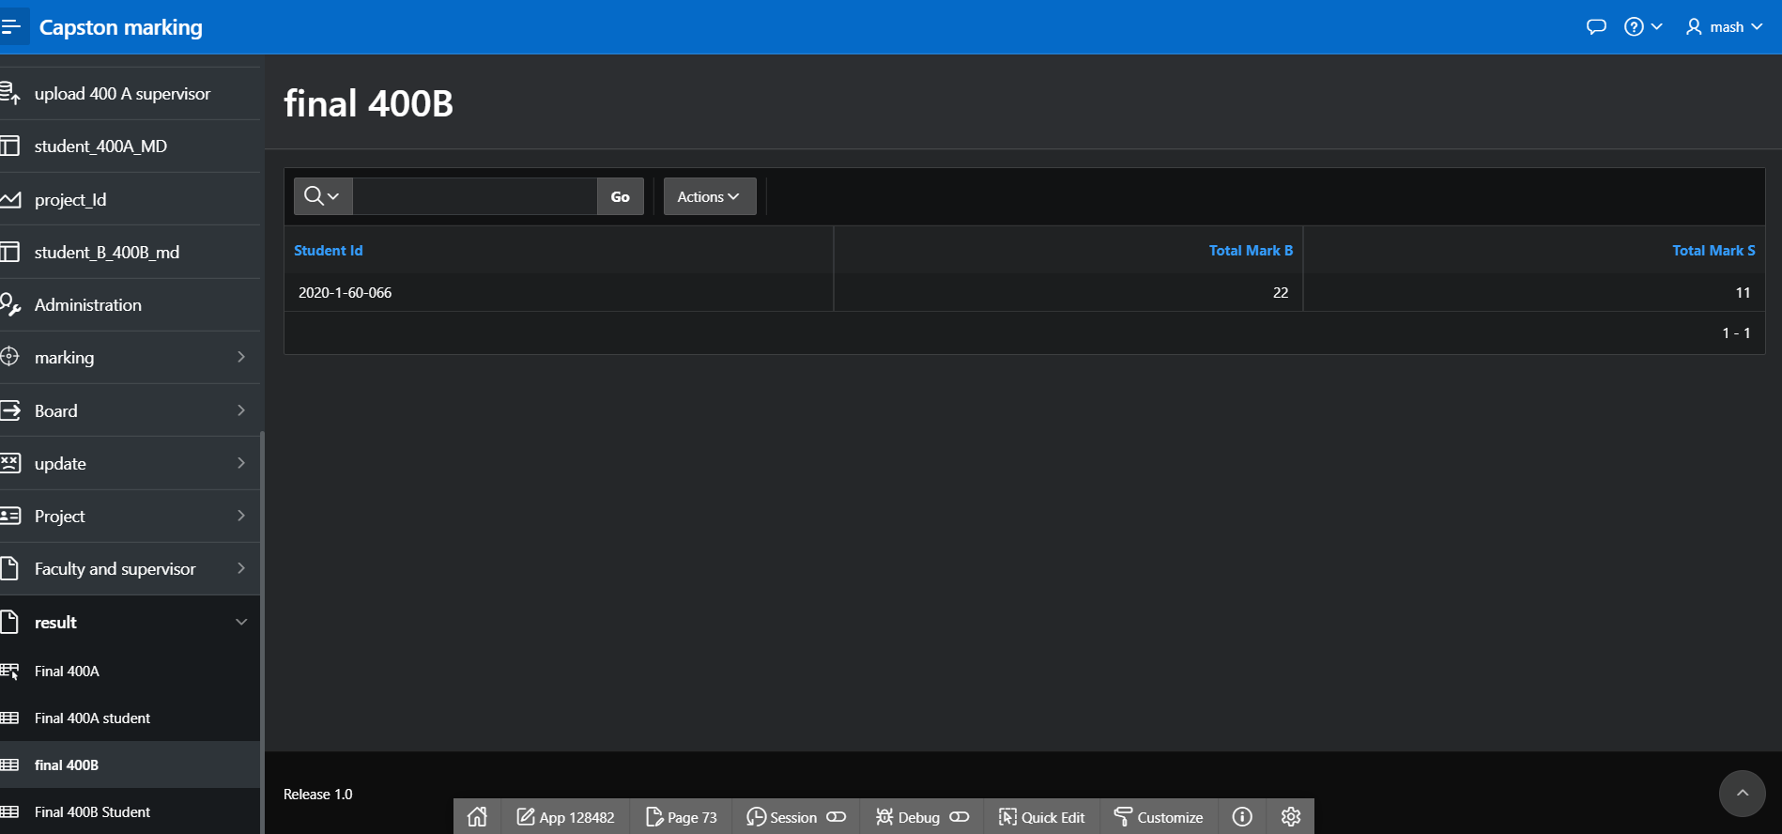

Figure 4.36: Final 400B

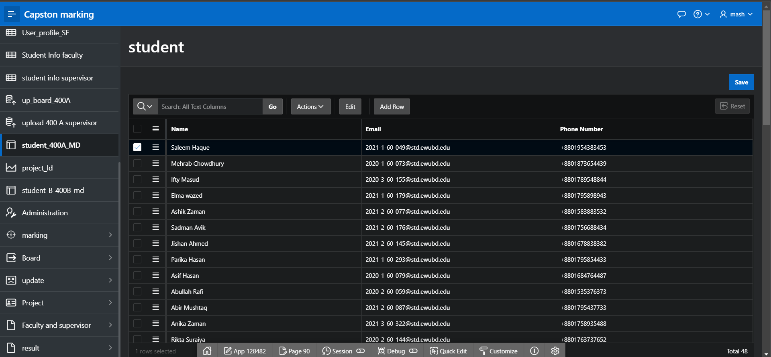

Figure 4.37: Student

# Master-Detail Form

| Page Number and Name | Master Table (Parent) | Detail Table (Child) |
| --- | --- | --- |
| student_400A_MD  page: 90 | student | SUP_MARKING_400A |
| Student_B_400B_MD  page:53 | student | SUP_MARKING_400B |
|  |  |  |
|  |  |  |
|  |  |  |
|  |  |  |

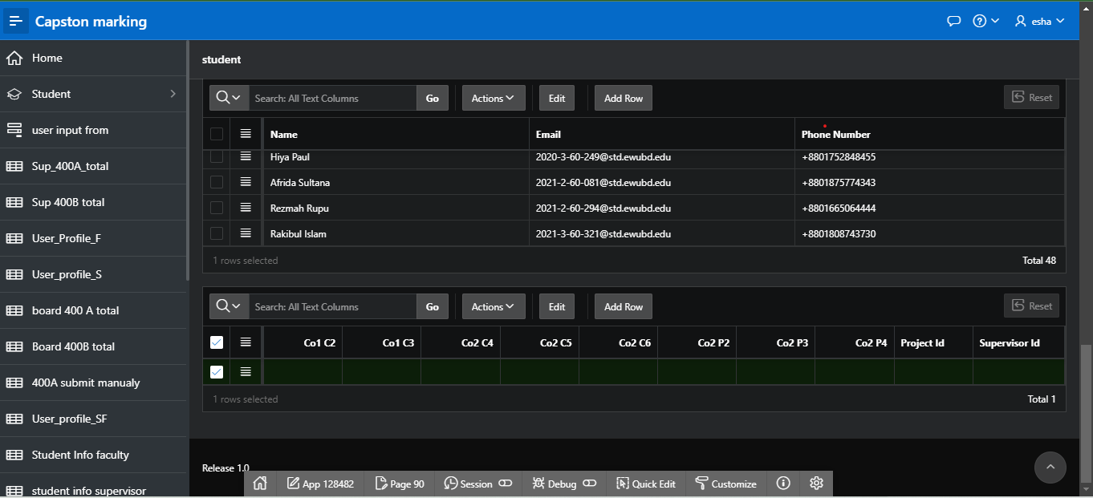

Figure 5.1:student_400A_MD Master-Detail Form

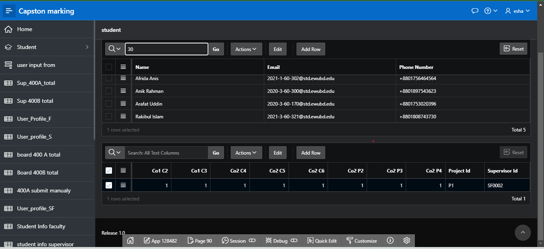

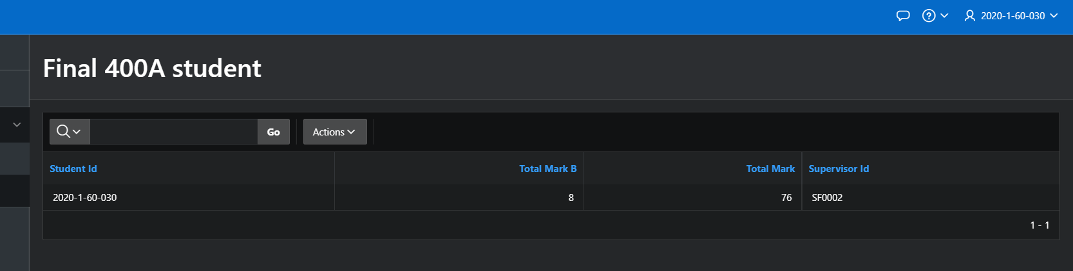

Figure 5.2:student_400A_MD Master-Detail Form after inputting 30 and showing the result

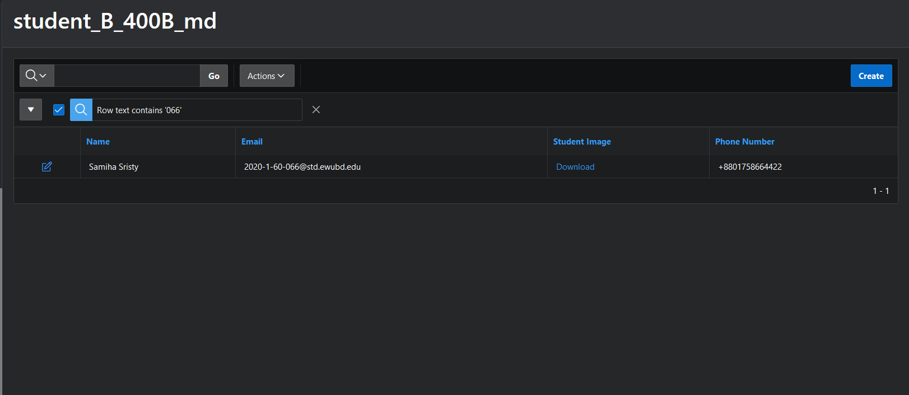

Fig 5.3: student_B_400B_MD Master-Detail Form(2nd Master-Detail Form)

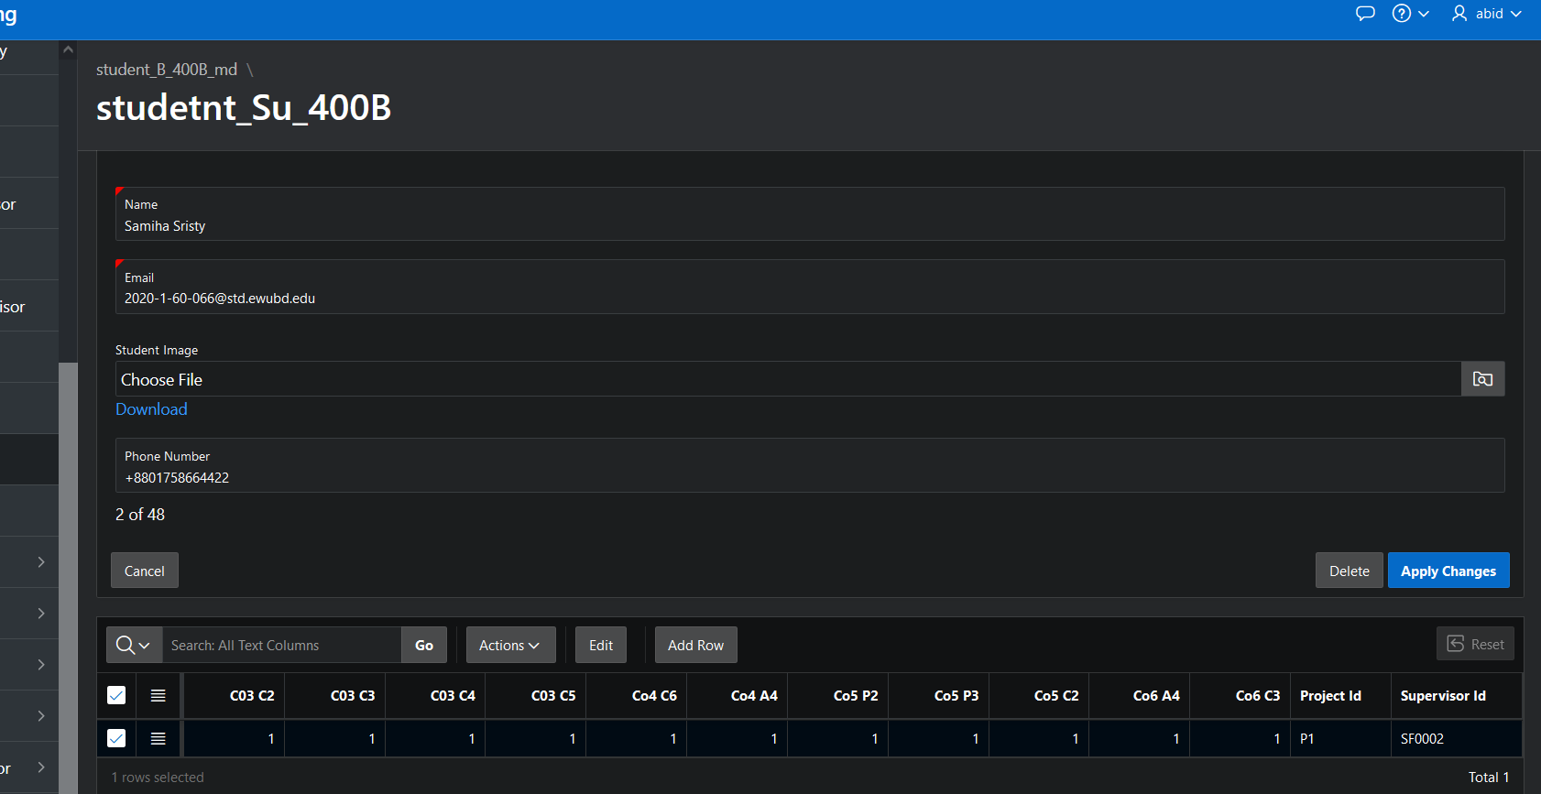

Figure 5.4:student_B_400B_MD Master-Detail Form after inputting Samiha Sristy(student info) and showing the result

# Reports based on Multi-Table and Aggregate Queries

| Page Number and Name | Query Type | Report description |
| --- | --- | --- |
| write your report page number and name here | Multi-table/Aggregate | write the description of the report in a simple sentence such as this report shows the total number of instructors per department. |
| User_Profile_F | aggregate | show information about faculty currently log in |
| BOARD_MEMBER_400B | aggregate | show name on the place of faculty id |
| User_Profile_SF | aggregate | show information about supervisor currently log in |
| user_profile_S | aggregate |  |
|  |  |  |

# Parameterized Reports

| Page Number and Name | Given Input | Report description |
| --- | --- | --- |
| User_Profile_F  PG14 | taken from login user id | individual faculty information. |
| User_Profile_S  PG48 | taken from login user id | individual student information |
| User_Profile_SF  PG49 | taken from login user id | individual supervisor information |
| Student Info Faculty  PG77 | taken from login user id | student information only under that faculty board |
| student info supervisor  PG79 | taken from login user id | supervisor see her student |
| 400A Sup marking form  PG40 | taken from login user id | supervisor ct |
| 400A Board mark form  PG20 | taken from login user id | give mark according to his assign student |
| 400B sup marking form  PG26 | taken from login user id | only mark of supervised student |
| 400B Board mark form  PG32 | taken from login user id | only mark of board student |
| Final 400A student  PG71 | taken from login user id | student see his own number in 400A |
| Final 400B student  PG75 | taken from login user id | student see his own number in 400B |

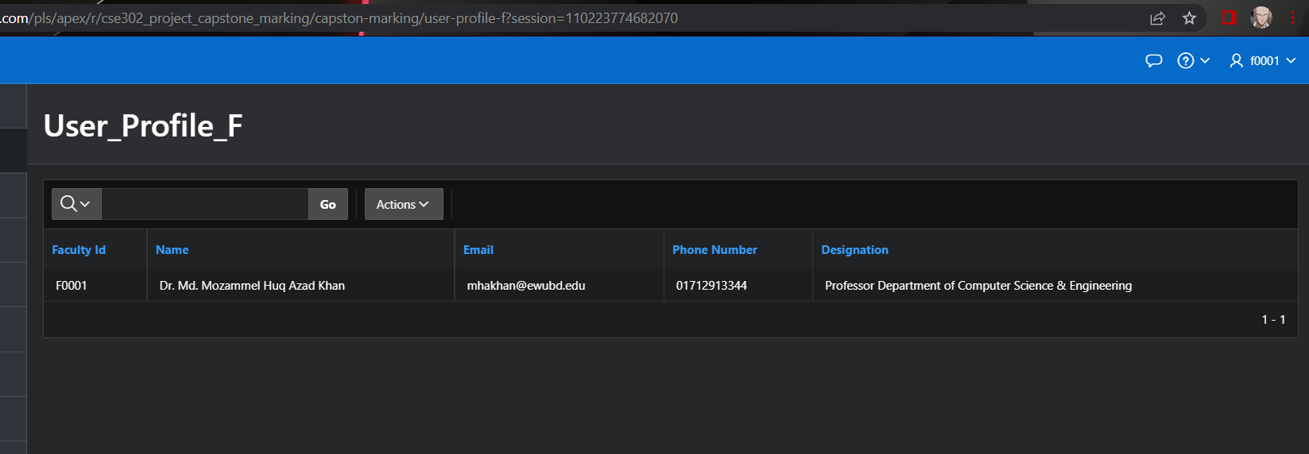

Fig 7.1: User_Profile_F

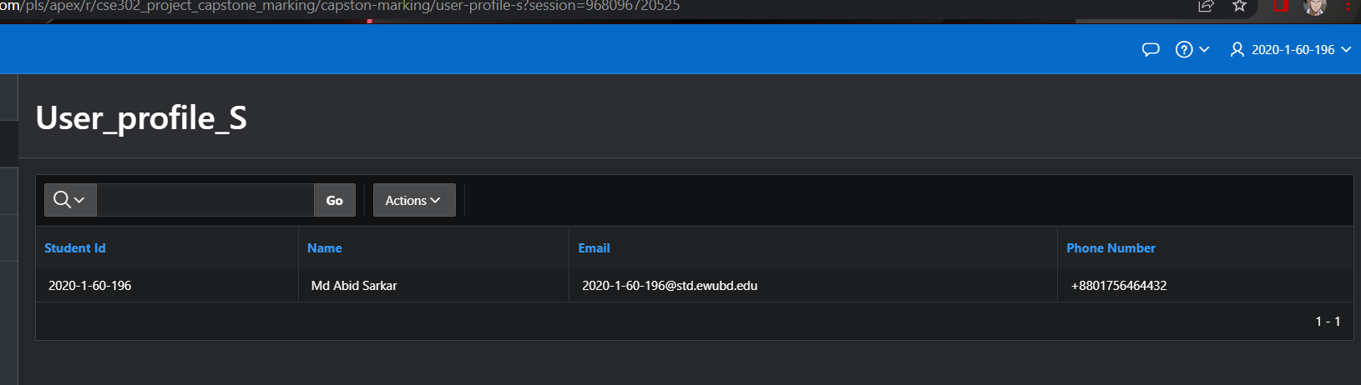

Fig:7.2 :User_Profile_S

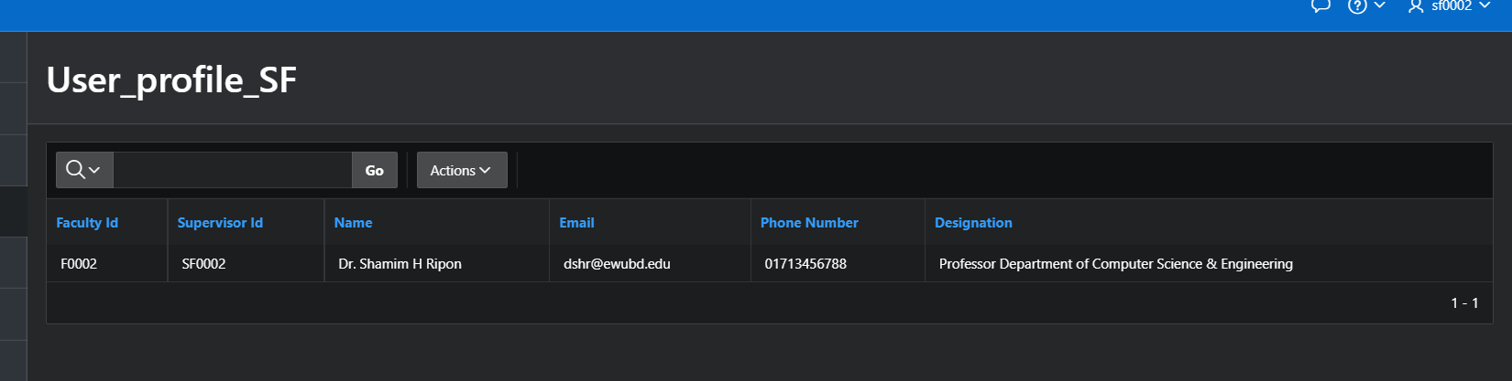

Fig:7.3 :User_Profile_SF

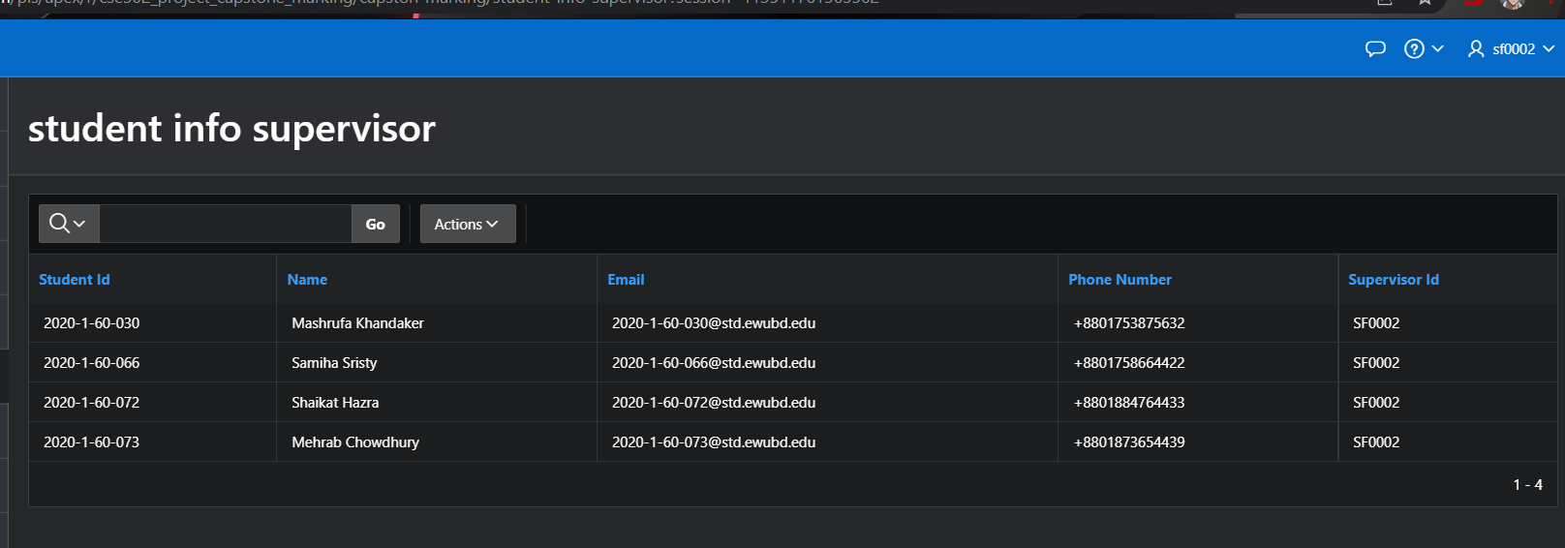

Fig:7.4 : student info supervisor

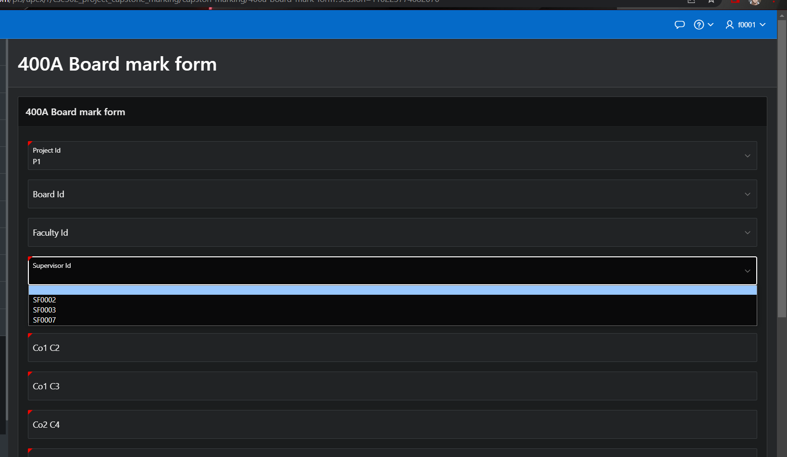

Fig:7. 5: 400A Board mark form

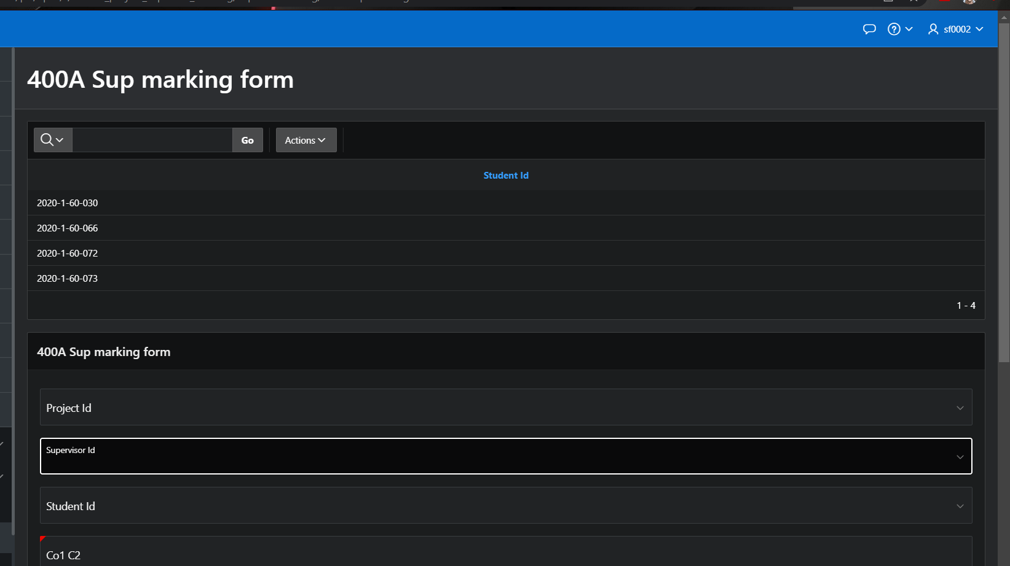

Fig: 7.6:400A Sup marking form

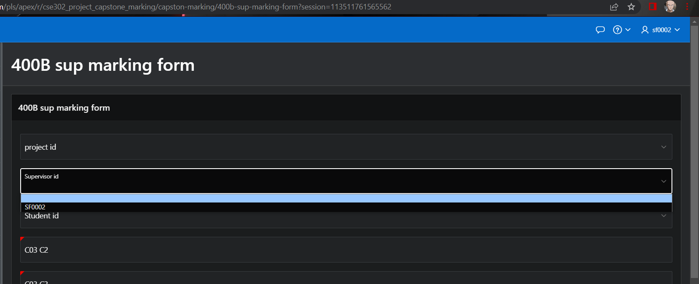

Fig: 7.7:400B sup marking form

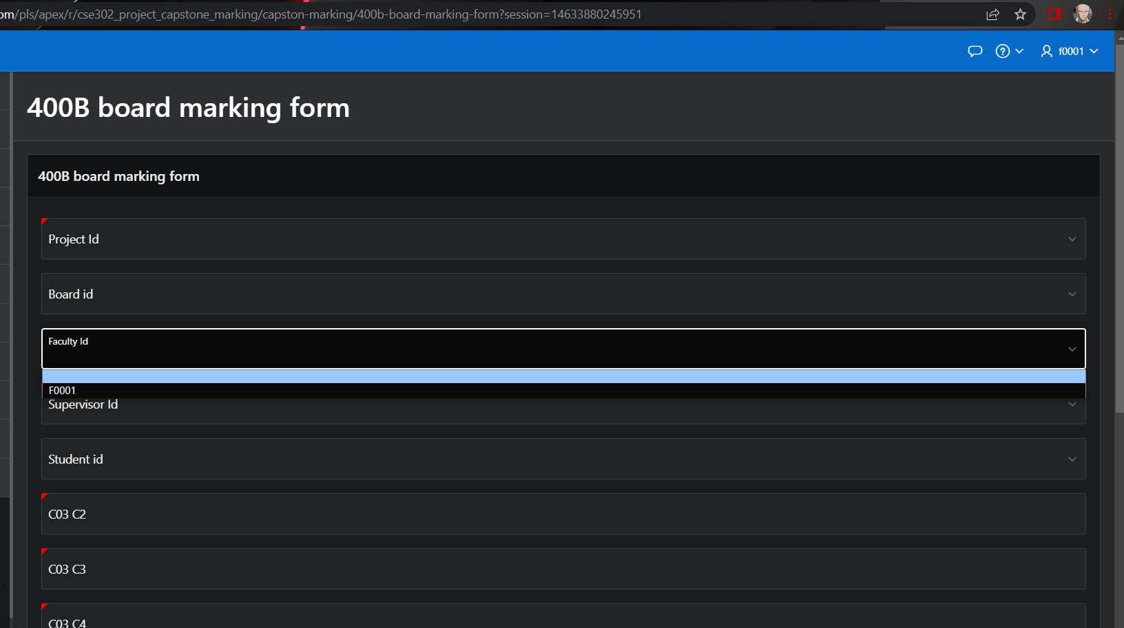

Fig: 7.8: 400B board marking form

# Charts and Other Pages

| Page Number and Name | Chart description |
| --- | --- |
| Charts-project id  Page-93 | Chart-This bar chart shows total number of project id |
| Charts-board member count  Page-93 | Chart-This bar chart shows how many board members are there |
| Charts-supervisor  Page-93 | Chart-This bar chart shows how many students are under a supervisor |
| Upload_board_400A  Page-81 |  |
| Upload 400A supervisor  Page-82 |  |
|  |  |

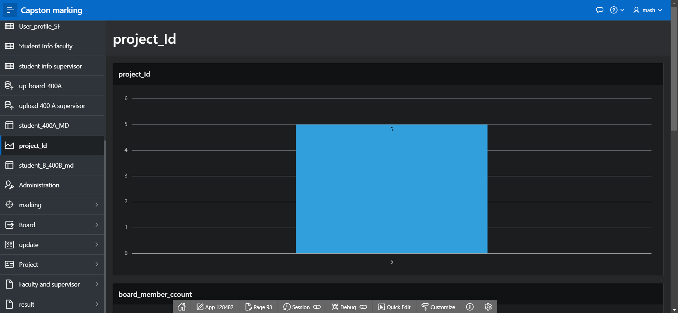

Figure 8.1: Charts-project id

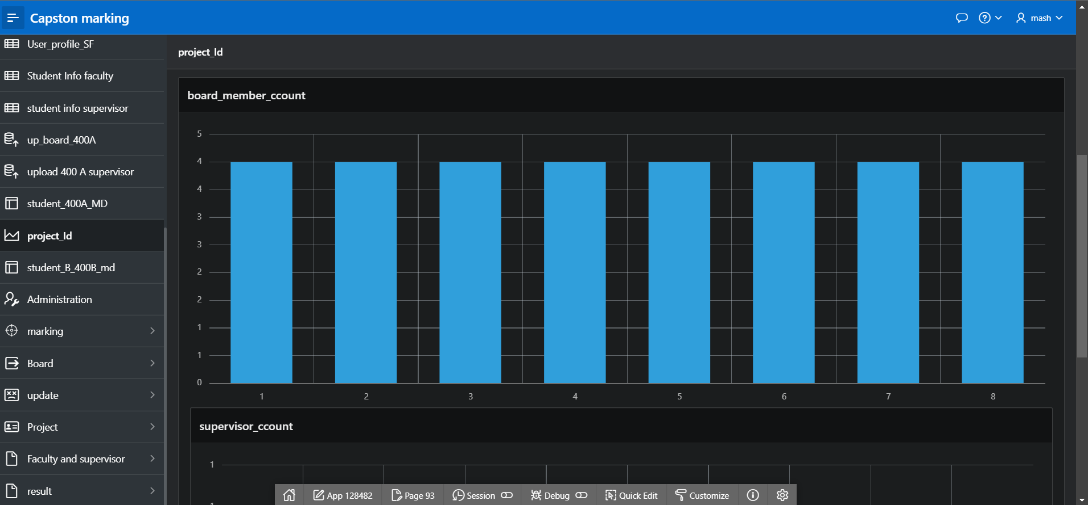

Figure 8.2: Charts-board member count

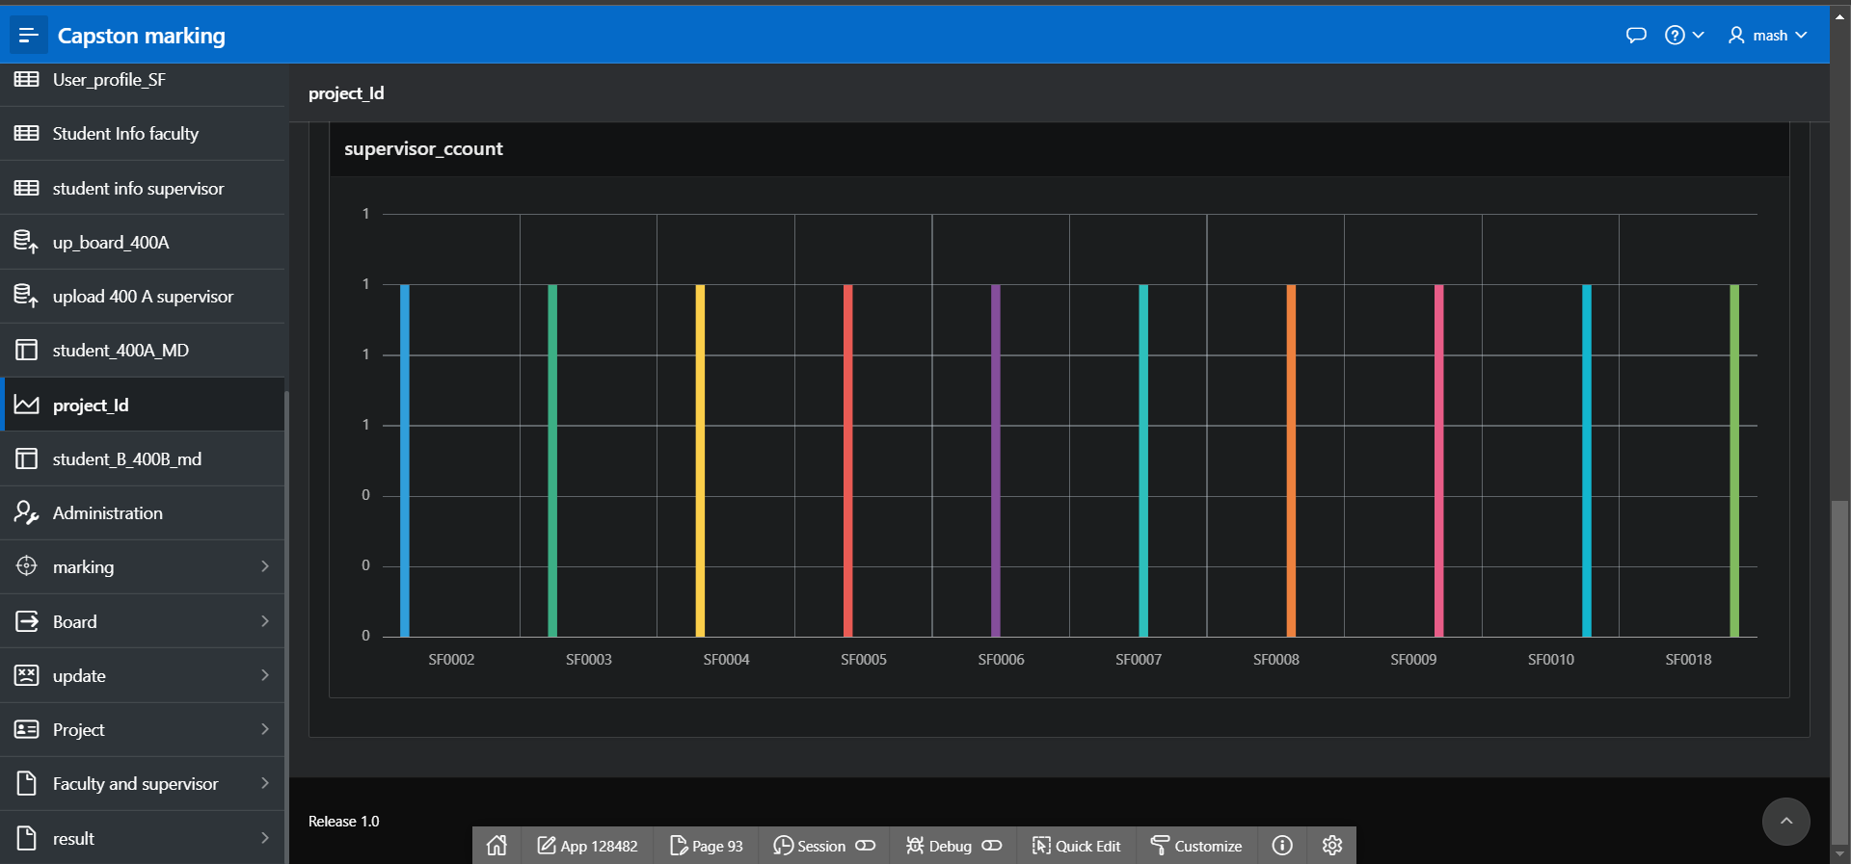

Figure 8.3: Charts-supervisor

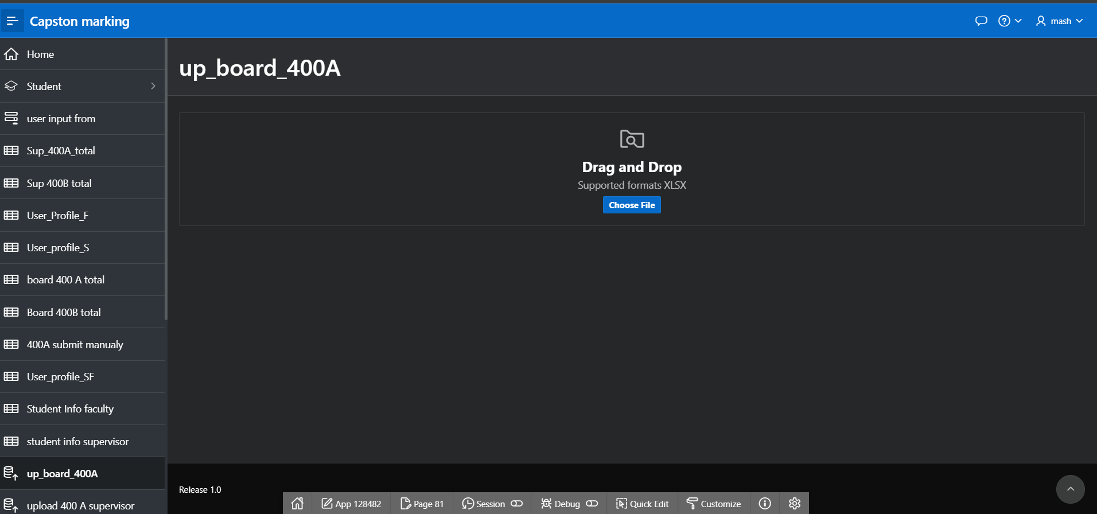

Figure 8.4:Upload board 400A

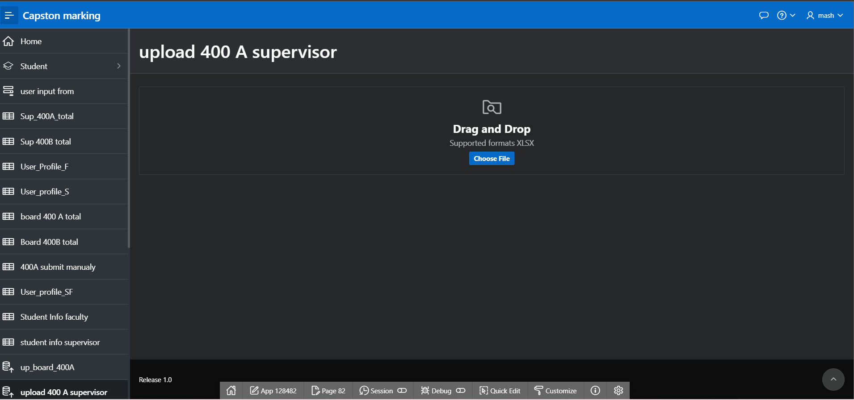

Figure 8.5:Upload 400A supervisor

# Authorization and User Role Assignment

**User Role Assignment**

| User name | Password | Role |
| --- | --- | --- |
| admin | admin123 | Administrator |
| abid | abid1234 | Administrator |
| 2020-1-60-196 | 1234 | Reader |
| 2020-1-60-075 | 1234 | | Reader | | --- | |
| 2020-1-60-030 | 1234 | Reader |
| 2020-1-60-066 | 1234 | Reader |
| 2020-1-60-079 | 1234 | Reader |
| 2020-1-60-080 | 1234 | Reader |
| 2020-1-60-072 | 1234 | Reader |
| 2020-1-60-073 | 1234 | Reader |
| 2020-2-60-167 | 1234 | Reader |
| 2020-2-60-144 | 1234 | Reader |
| 2020-2-60-289 | 1234 | Reader |
| 2020-2-60-059 | 1234 | Reader |
| 2020-2-60-207 | 1234 | Reader |
| 2020-2-60-083 | 1234 | Reader |
| 2020-2-60-111 | 1234 | Reader |
| 2020-2-60-073 | 1234 | Reader |
| 2020-3-60-155 | 1234 | Reader |
| 2020-3-60-300 | 1234 | Reader |
| 2020-3-60-016 | 1234 | Reader |
| 2020-3-60-158 | 1234 | Reader |
| 2020-3-60-268 | 1234 | Reader |
| 2020-3-60-249 | 1234 | Reader |
| 2020-3-60-003 | 1234 | Reader |
| 2020-3-60-170 | 1234 | Reader |
| 2021-1-60-049 | 1234 | Reader |
| 2021-1-60-245 | 1234 | Reader |
| 2021-1-60-179 | 1234 | Reader |
| 2021-1-60-293 | 1234 | Reader |
| 2021-1-60-373 | 1234 | Reader |
| 2021-1-60-007 | 1234 | Reader |
| 2021-1-60-178 | 1234 | Reader |
| 2021-1-60-302 | 1234 | Reader |
| 2021-2-60-081 | 1234 | Reader |
| 2021-2-60-077 | 1234 | Reader |
| 2021-2-60-176 | 1234 | Reader |
| 2021-2-60-294 | 1234 | Reader |
| 2021-2-60-221 | 1234 | Reader |
| 2021-2-60-162 | 1234 | Reader |
| 2021-2-60-145 | 1234 | Reader |
| 2021-2-60-087 | 1234 | Reader |
| 2021-3-60-254 | 1234 | Reader |
| 2021-3-60-145 | 1234 | Reader |
| 2021-3-60-321 | 1234 | Reader |
| 2021-3-60-013 | 1234 | Reader |
| 2021-3-60-322 | 1234 | Reader |
| 2021-3-60-092 | 1234 | Reader |
| 2021-3-60-186 | 1234 | Reader |
| 2021-3-60-089 | 1234 | Reader |
| F0001 | F1234 | Contributor |
| F0002 | F1234 | Contributor |
| F0003 | F1234 | Contributor |
| F0004 | F1234 | Contributor |
| F0005 | F1234 | Contributor |
| F0006 | F1234 | Contributor |
| F0007 | F1234 | Contributor |
| F0008 | F1234 | Contributor |
| F0009 | F1234 | Contributor |
| F0010 | F1234 | Contributor |
| F0011 | F1234 | Contributor |
| F0012 | F1234 | Contributor |
| F0013 | F1234 | Contributor |
| F0014 | F1234 | Contributor |
| F0015 | F1234 | Contributor |
| F0016 | F1234 | Contributor |
| F0017 | F1234 | Contributor |
| F0018 | F1234 | Contributor |
| F0019 | F1234 | Contributor |
| F0020 | F1234 | Contributor |
| F0021 | F1234 | Contributor |
| F0022 | F1234 | Contributor |
| F0023 | F1234 | Contributor |
| F0024 | F1234 | Contributor |
| F0025 | F1234 | Contributor |
| F0026 | F1234 | Contributor |
| SF0001 | *Sf1234* | Contributor SF |
| SF0002 | *Sf1234* | Contributor SF |
| SF0003 | *Sf1234* | Contributor SF |
| SF0004 | *Sf1234* | Contributor SF |
| SF0005 | *Sf1234* | Contributor SF |
| SF0006 | *Sf1234* | Contributor SF |
| SF0007 | *Sf1234* | Contributor SF |
| SF0008 | *Sf1234* | Contributor SF |
| SF0009 | *Sf1234* | Contributor SF |
| SF0010 | *Sf1234* | Contributor SF |
| SF0018 | *Sf1234* | Contributor SF |

**Page-wise Authorization Information**

| Page number and name | Authorization Level |
| --- | --- |
| P10. Home |  |
| P12. Student | Administrator |
| P30. Student form | Administrator |
| P50. faculty form |  |
| P70. Board member form |  |
| P80. Board member report |  |
| P90. supervisor form |  |
| P120. project form | Administrator |
| P130. project report | Administrator |
| P140. project member report |  |
| P150. project member form |  |
| P170. 400A sup mark report |  |
| P180 supervisor report |  |
| P190 400A sup mark report |  |
| P200. user input form | Administrator |
| P210. student report |  |
| P220. Faculty report |  |
| P230. 400A Board mark form |  |
| P240. 400 board marking report |  |
| P250. 400B sup marking form |  |
| P260. 400B sup marking report |  |
| P270. 400B board marking form |  |
| P280. 400B board marking report |  |
| P290. Sup_400A_total | Administrator |
| P300. Sup_400B_total | Administrator |
| P310. User_Porfile_F | Contributor |
| P320. User_Porfile_S | Reader |
| P330. supervisor_list |  |
| P340. board 400A total | Administrator |
| P350. board 400B total | Administrator |
| P360. 400A submit manually | Administrator |
| P380. update_faculty | Administrator |
| P390. Update mark sup400A | Contributor |
| P400.Update mark sup400B | Contributor |
|  |  |
| P410.Update_mark_B_400A | Contributor |
| P420.Update_mark_B_400B | Contributor |
| P430. User_profile_SF | Contributor |
| P440. Final 400A | Contributor |
| P450. Final 400A student |  |
| P460. final 400B | Contributor |
| P470. Final 400B student |  |
| P480. Student Info Faculty | Contributor |
| P490. student info supervisor | Contributor |
| P500. up_board_400A | Contributor |
| P510. upload 400A supervisor | Contributor |
| P520. student_400A_MD |  |
| P530. project_Id | Contributor |
| P540. student_B_400B_md |  |
| P10000. Administration | Administrator |
| P10010. marking | Contributor |
| P10020. mark 400A |  |
| P10030. mark 400B |  |
| P10040. Board | Administrator |
| P10050. update | Contributor |
| P10060. Project | Administrator |
| P10070. Faculty and supervisor | Administrator |
| P10080. result | Reader |

Note:we use drop down mane and if we just give authorization to parents so child also came under it

# Concluding Remarks

we think we just unlocked an achievement of our life about the most hard working project as well as the most record frustration in a week. collecting information is also challenging . communicate with group members and work in a srinqonize way . As oracle sql is new to us. and neglected by people so learning some topics becomes so hard. Most of the tutorial in youtube is on mysql or other sql. Not only sql we have to learn basic css also.working on trigger is so hard part in this project . all trigger work perfectly beside 2 which have multiple column .i try so many time in different way but in the final could not make it thats why we have to show total result in 2 part. but end of the day we all 3 member is so happy about our work. we try our best to make the project good. if we got little more day the project might have some more function like notification, calendar event information . attach gmail api so we can send mail to each student after result published. user can change his password, more colorful icon, add animation and many more but in a short time those are just writing in a chake list. but the function we create is our archive at thai moomment. there is a say “if your code does not work well make it version 1.0” we might work in this project further and make it properly acceptable to all.